Staging Phase(Unit testing done on static pages-server not called yet)

Adv – Faster response time

Test Case 1 – Test if the home page is called correctly along with its metadata.

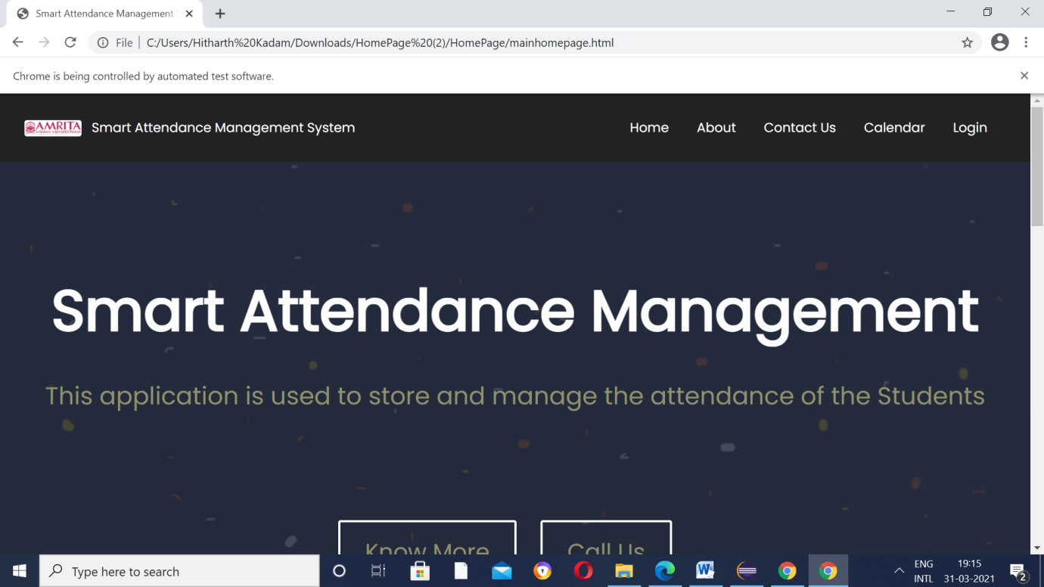

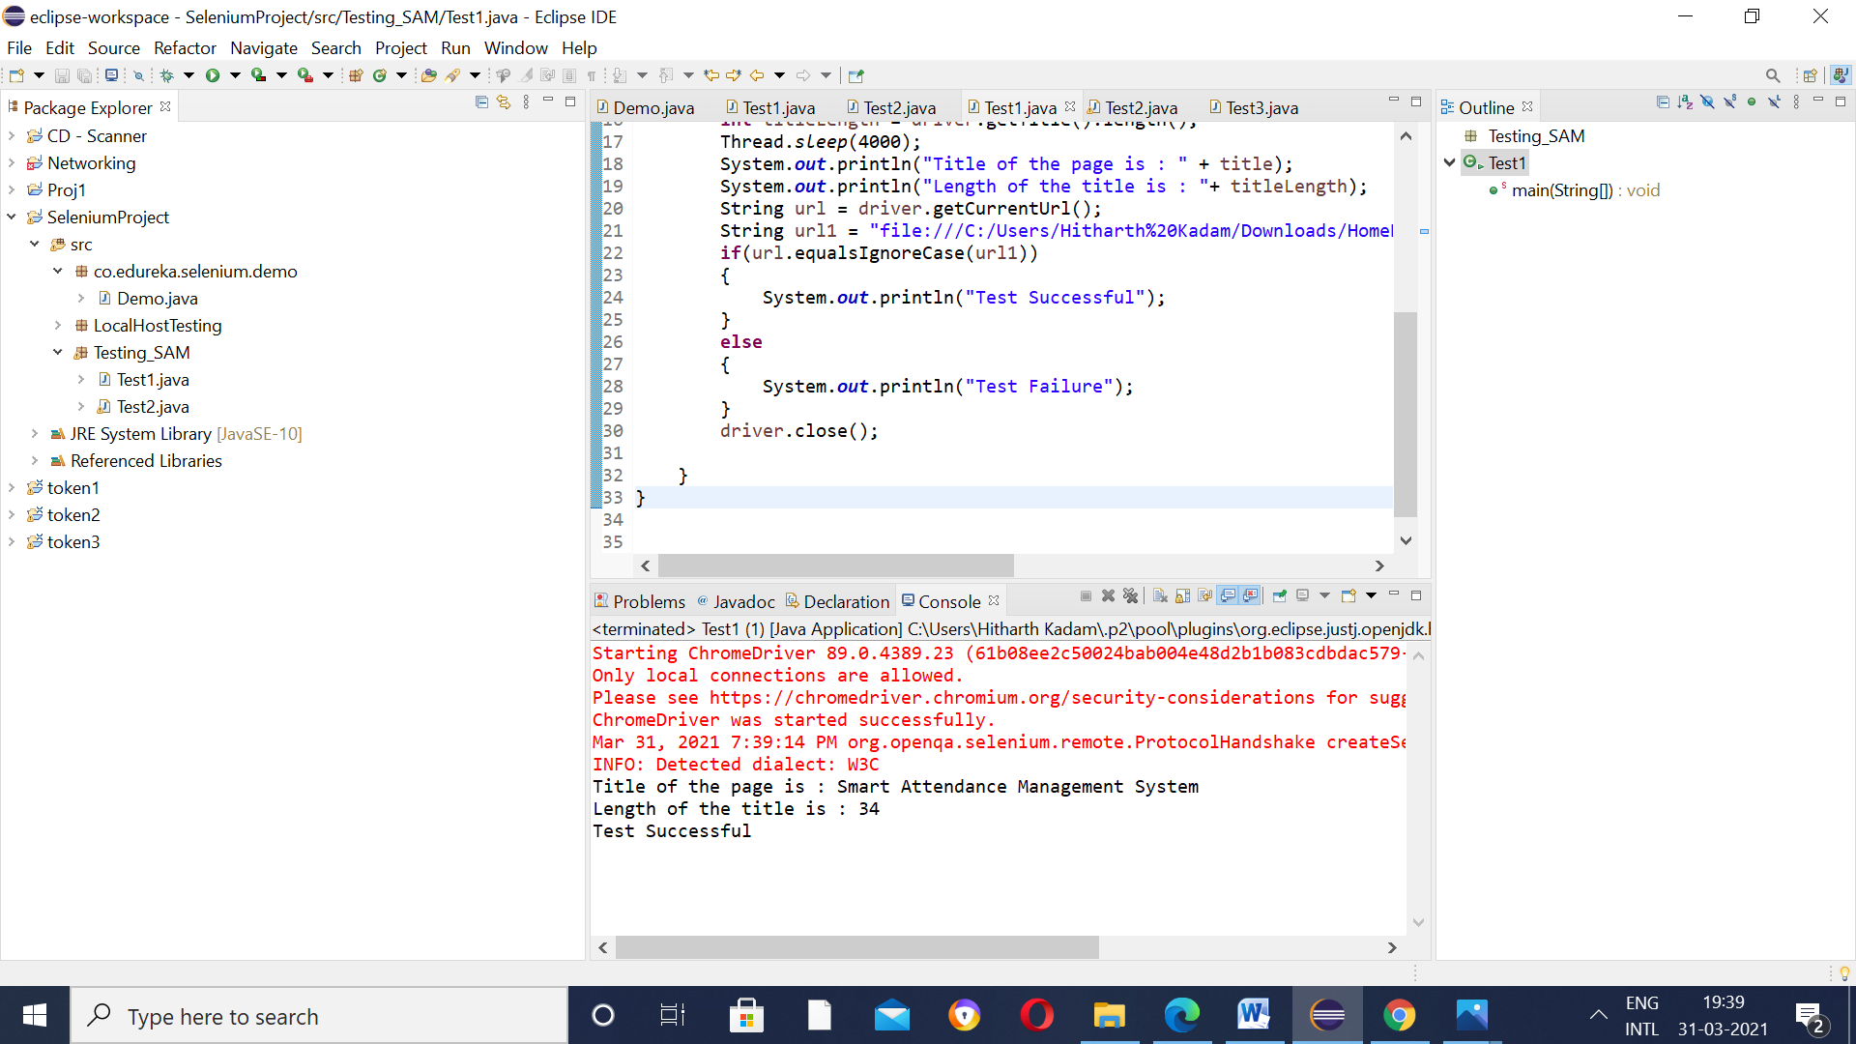

Test Case 2 – Test if the “Know More” button works correctly.

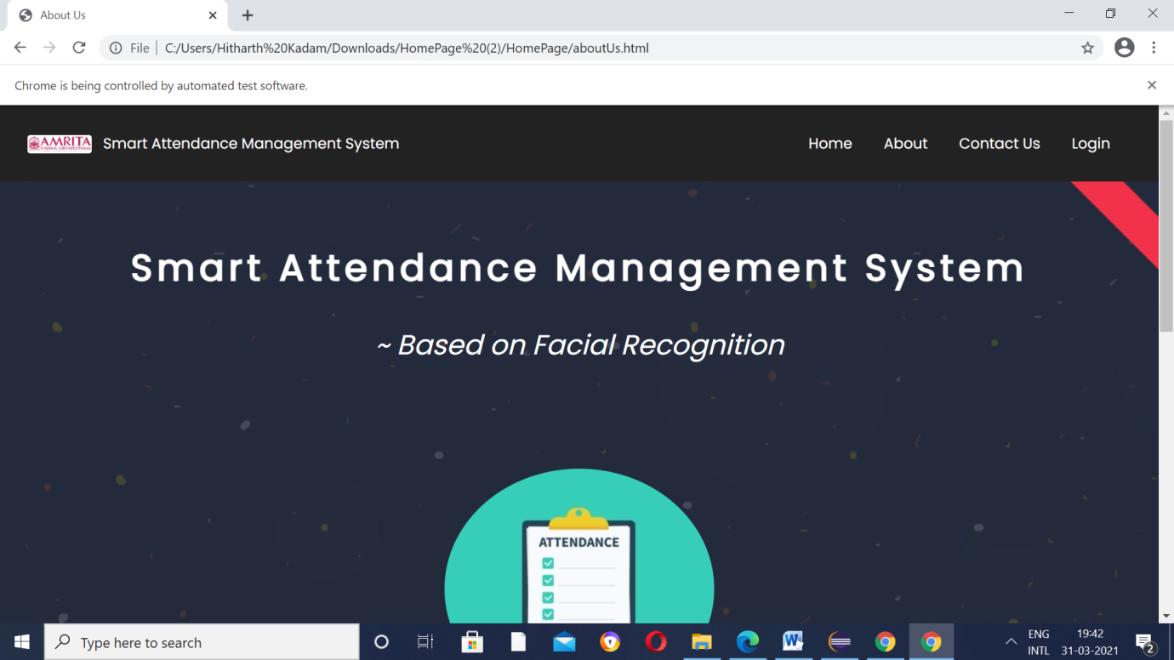

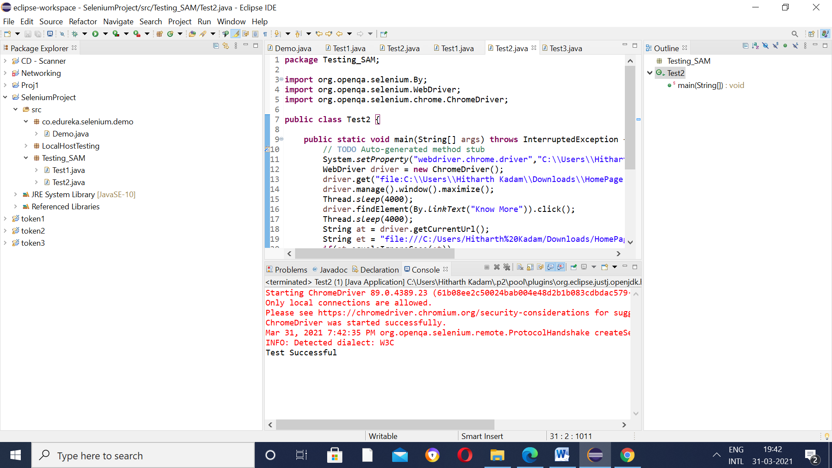

Test Case 3 - Test if the “Call Us” button works correctly.

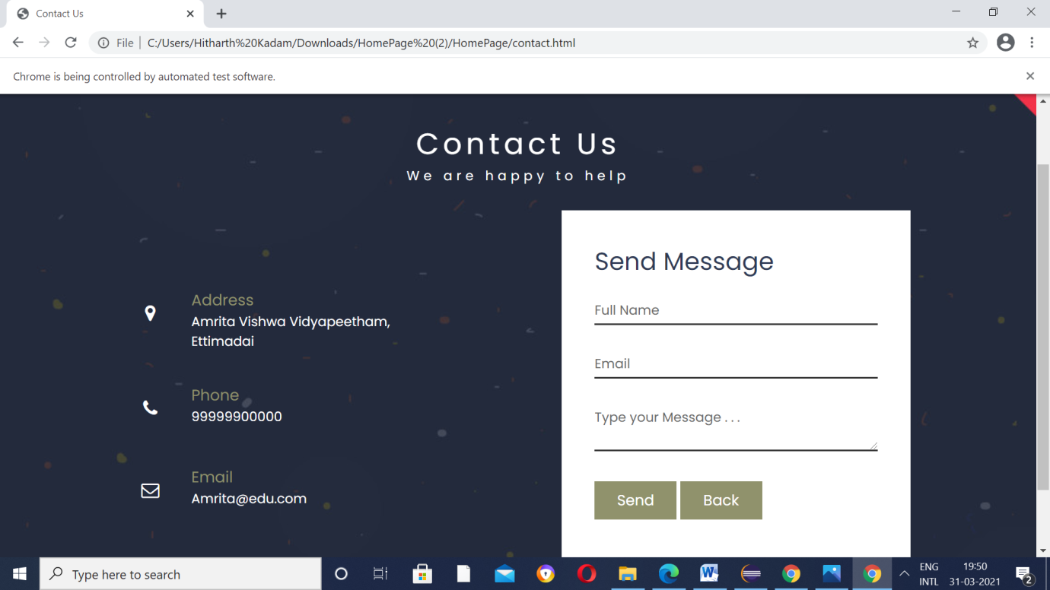

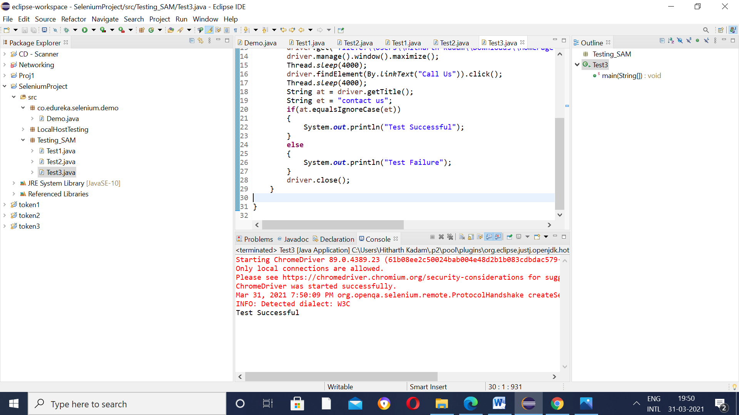

Test Case 4 – Test if the “Home” button in the navigation bar redirects to the Home Page.

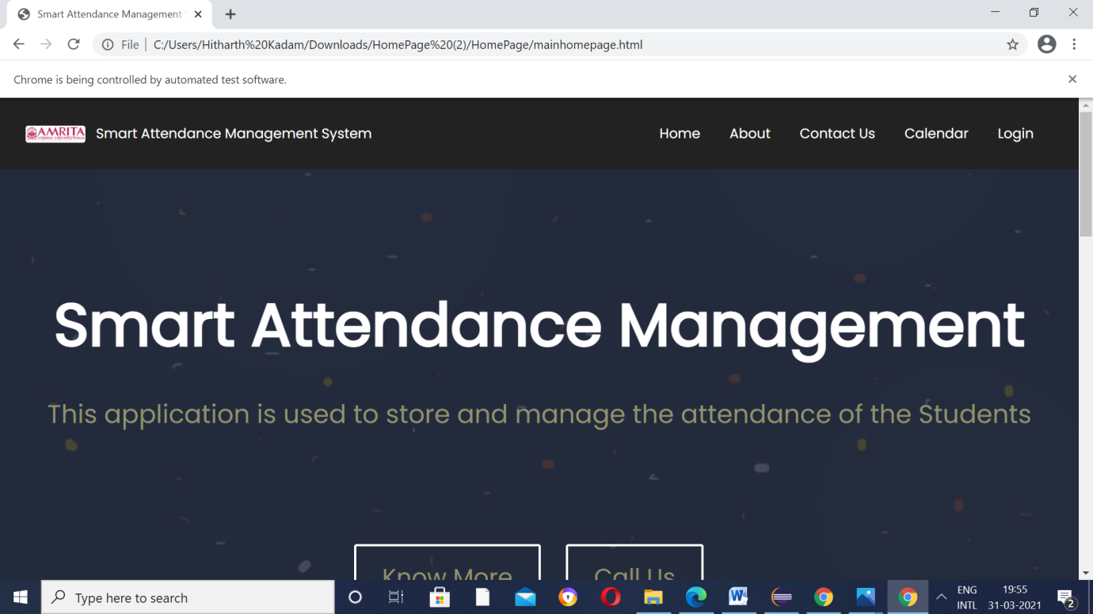

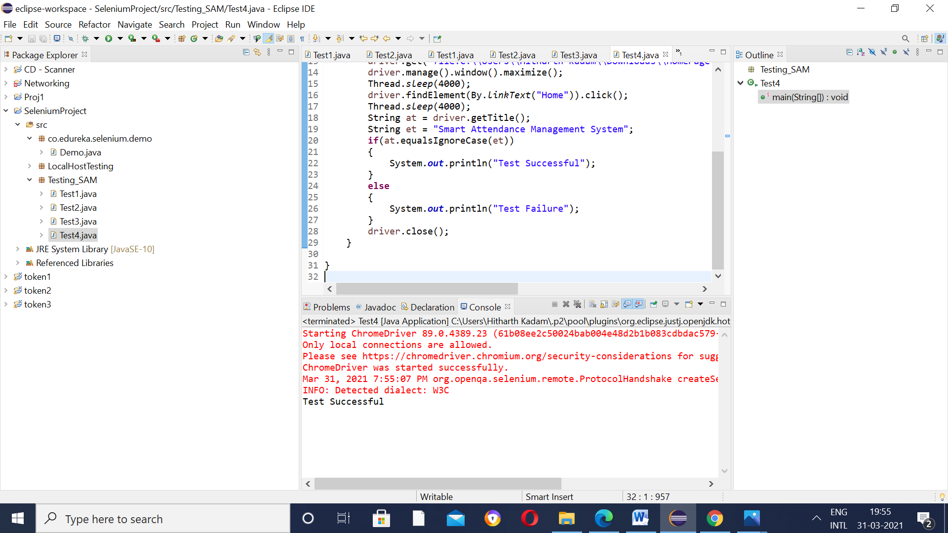

Test Case 5 – Test if the “About” Button in the navigation bar works in the same way as Know More Button.



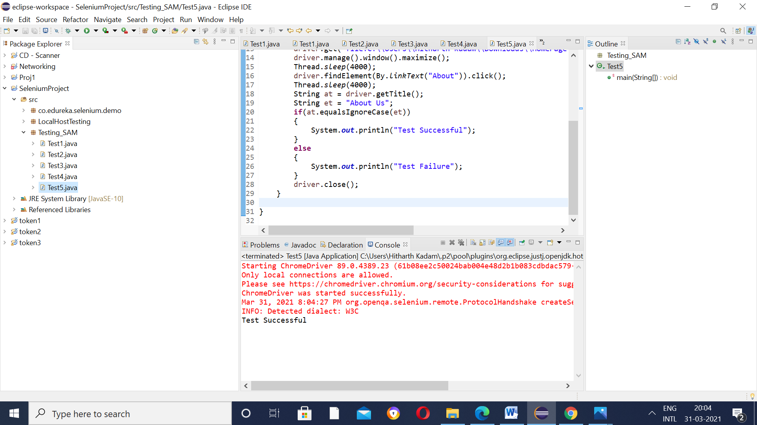

Test Case 6 – As developed,test if the Contact Us and Call Us buttons redirect to the same page.



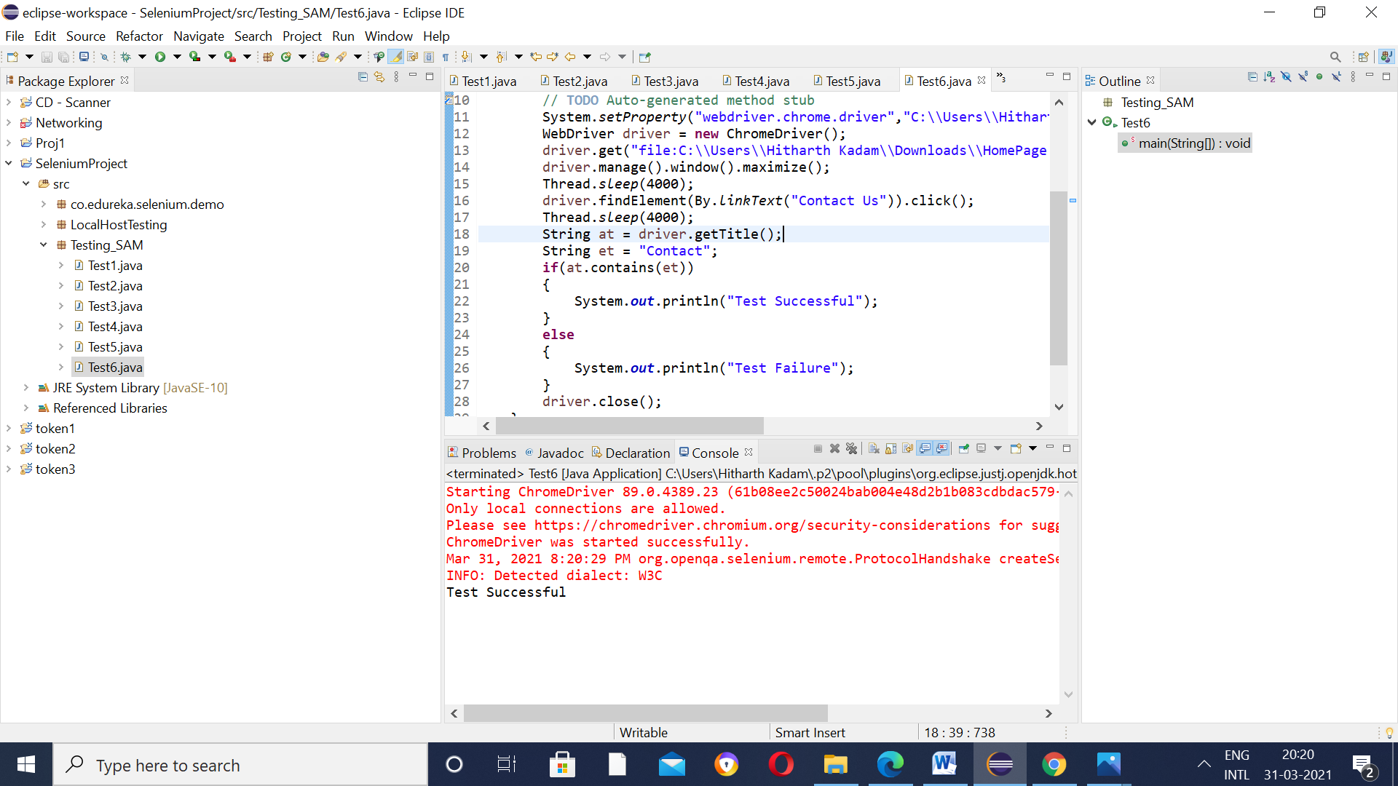

Test Case 7 – In the Home Page,Check the redirection to the Calendar page on clicking the Calendar button.

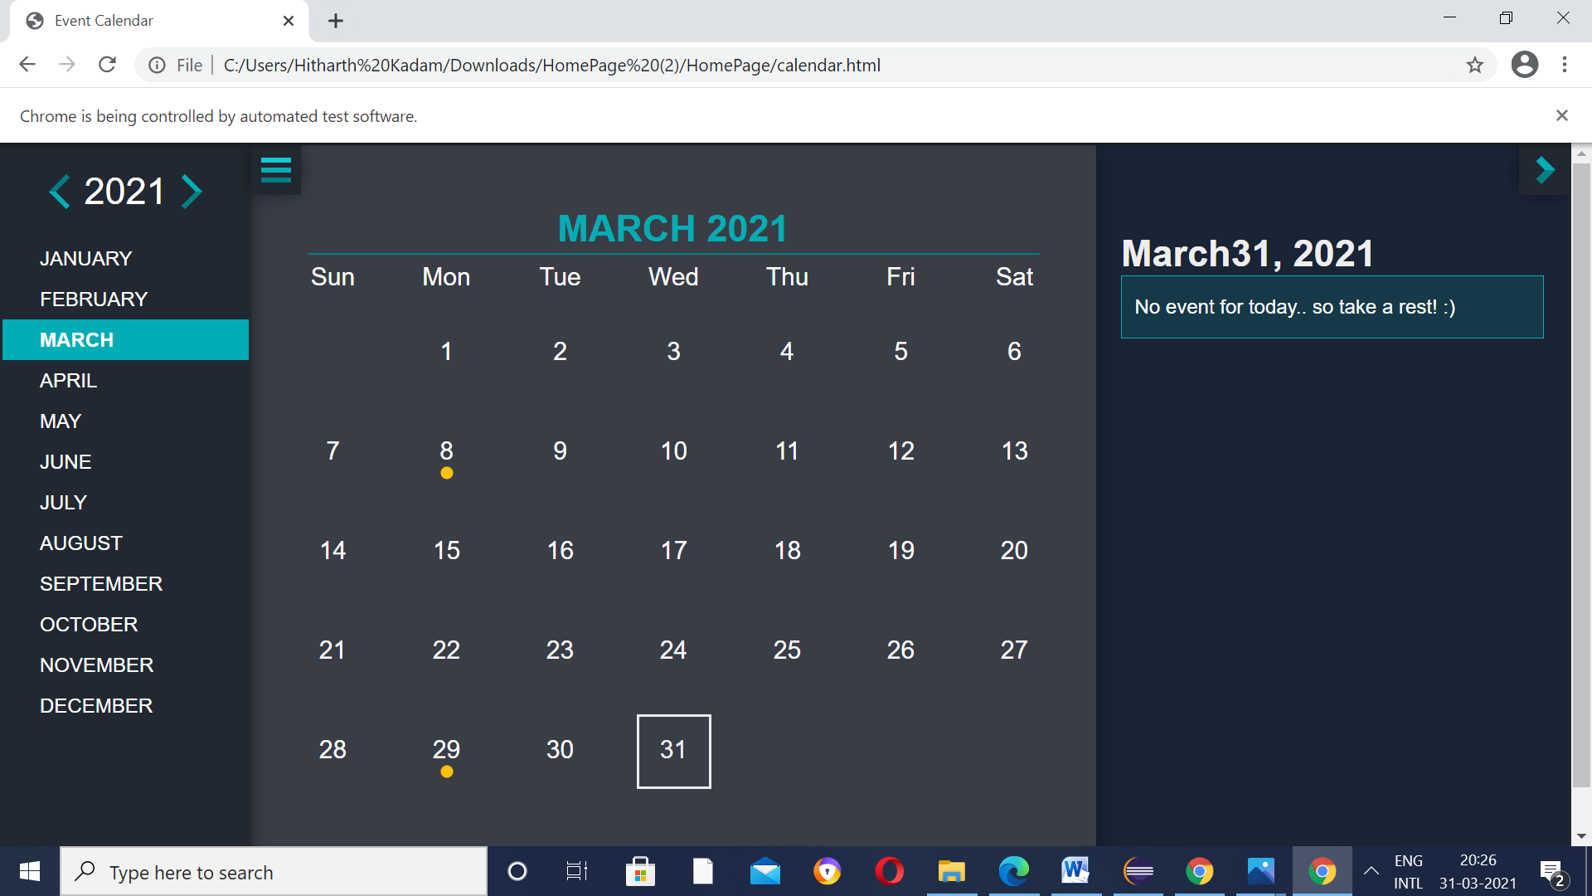

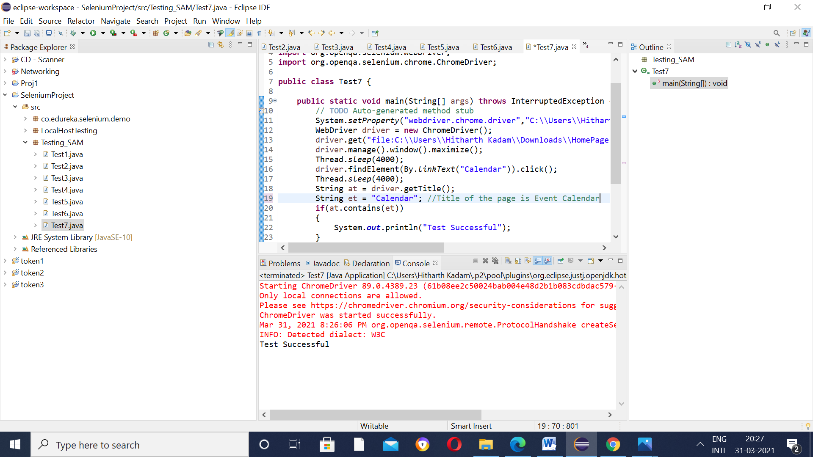

Production phase(Testing on running server)

Now let us take a look at something interesting,

Test Case 8 – If you remember Test Case 5(Check if the About Button works)

Test if the same About button works correctly on the running server.

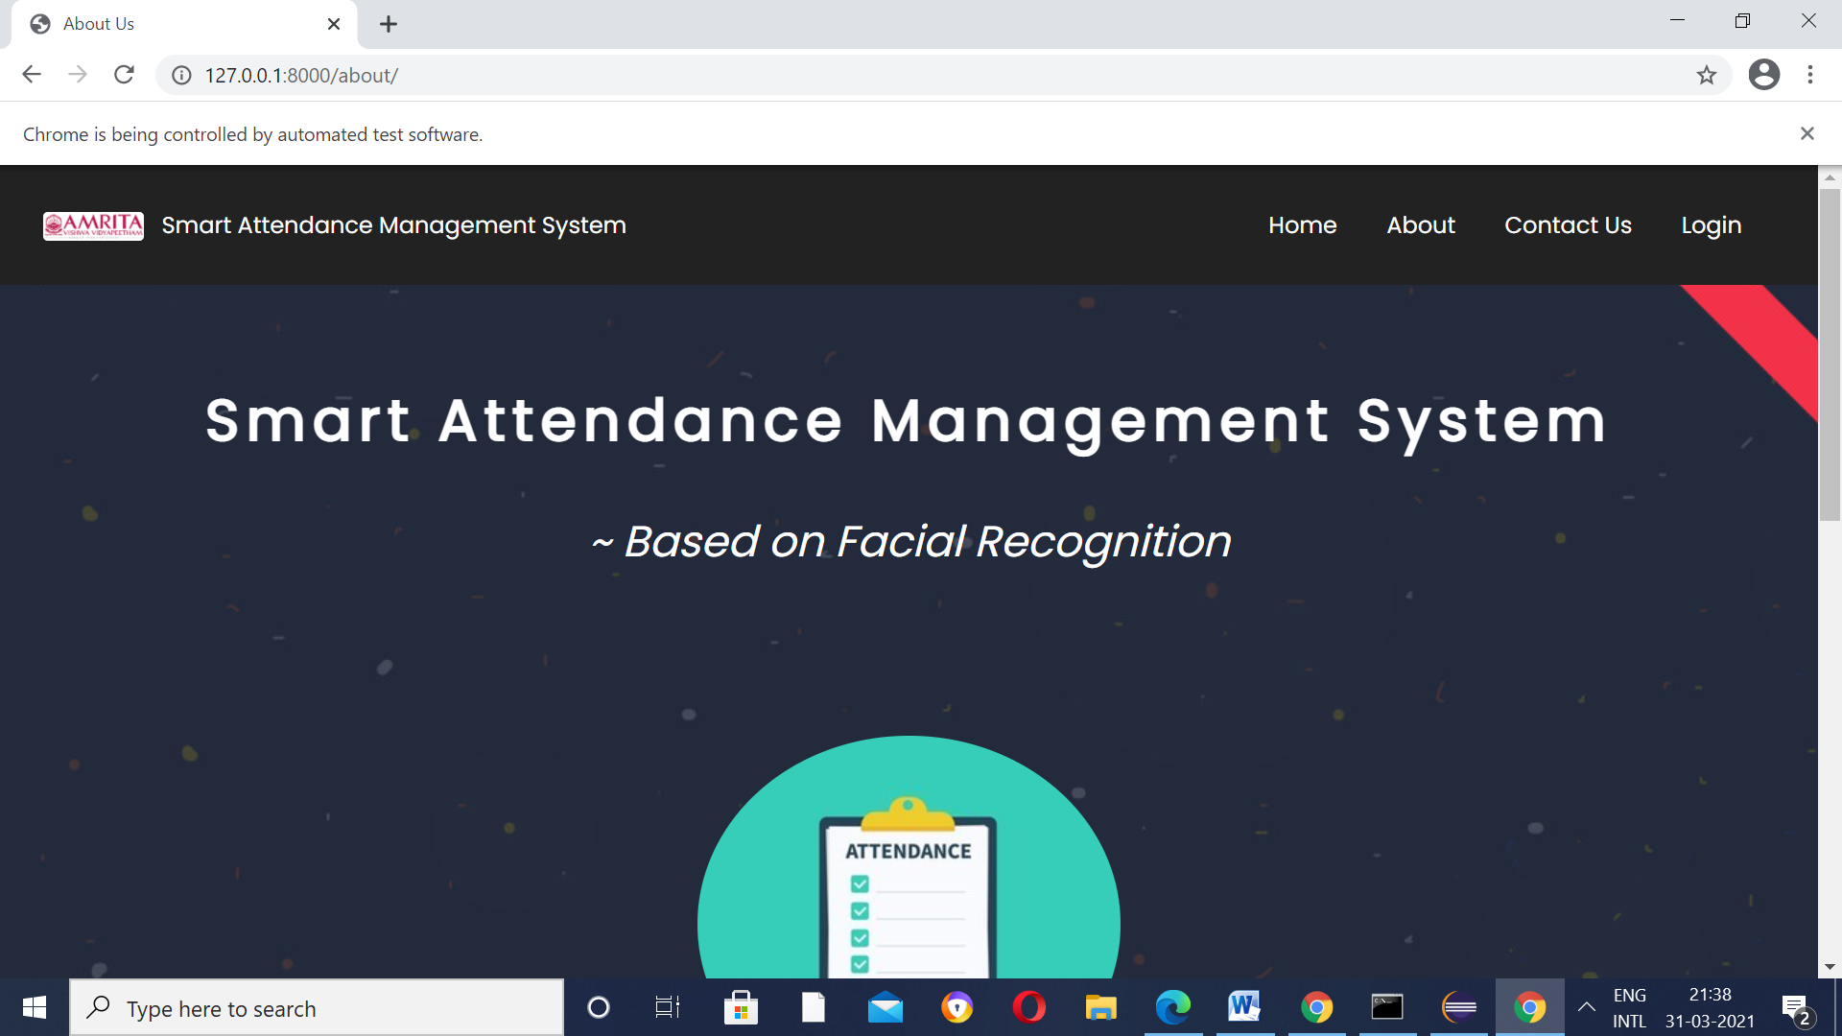

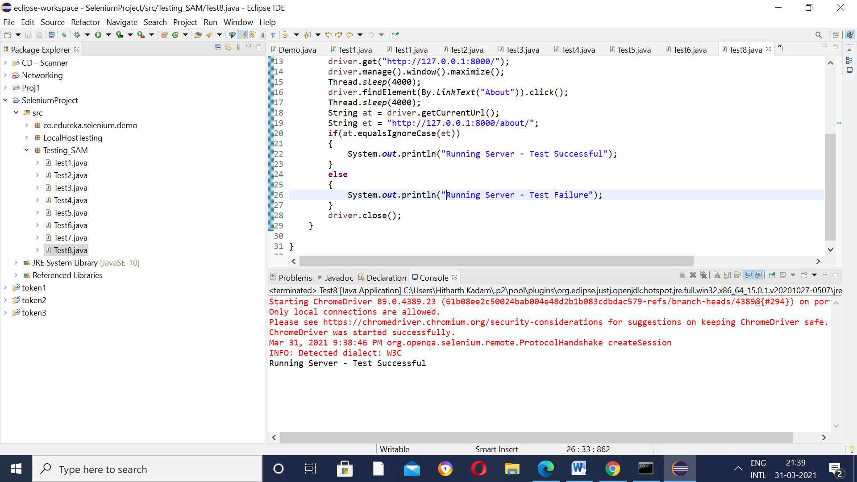

Test Case 9 – Test if the transition from the Home Page to the Login page works smoothly.

Prev. Login Page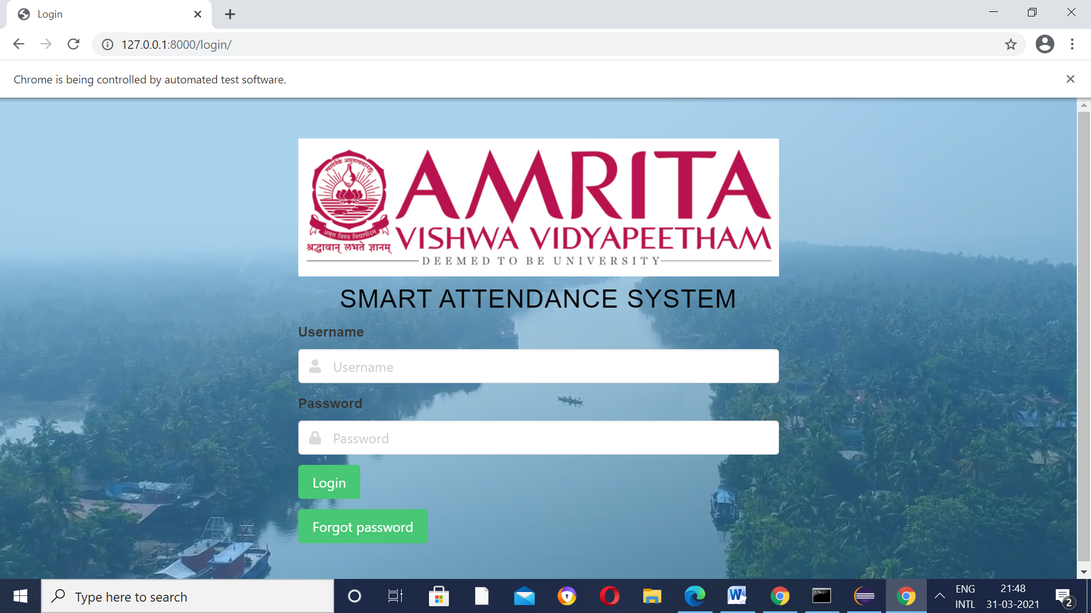

New Login Page

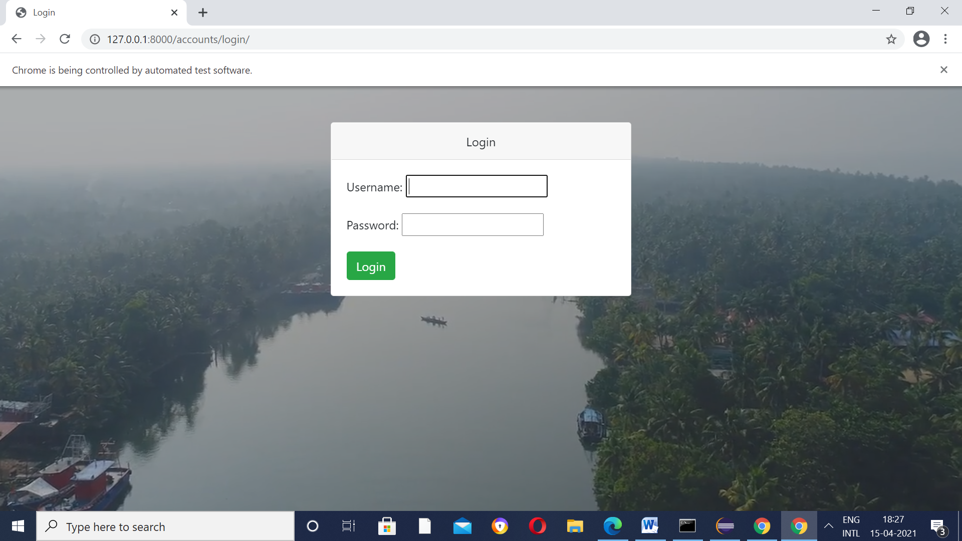

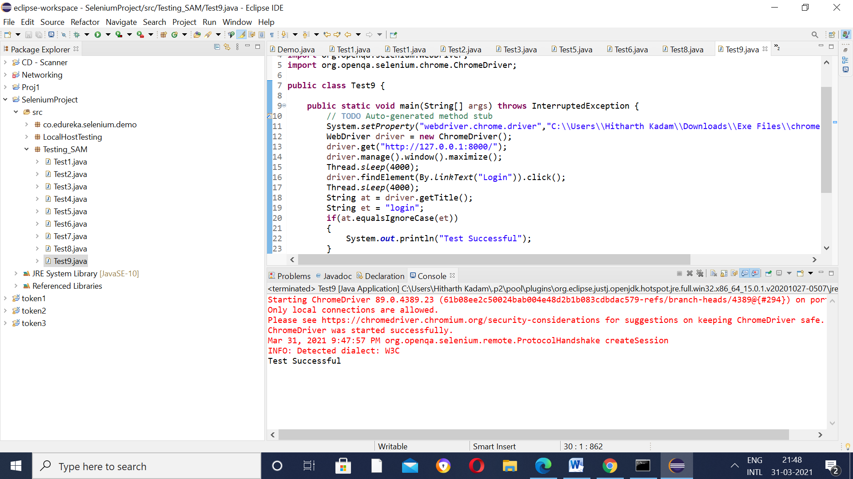

Test Case 10 – Test Login Page(for Student 1 - Priyatham)

Previously,

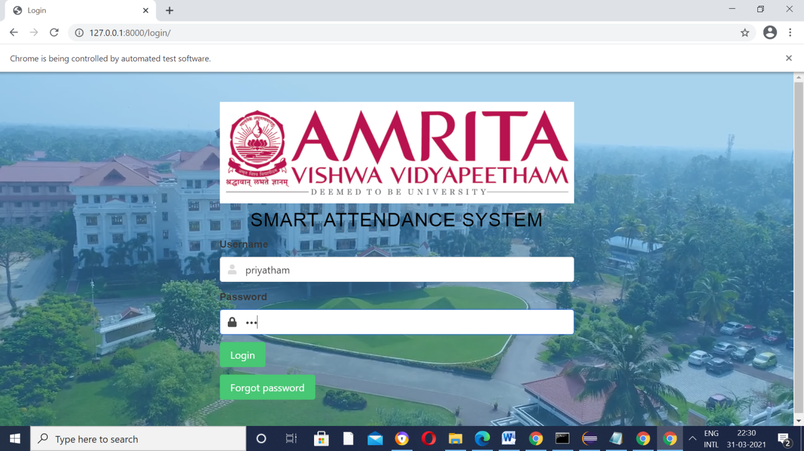

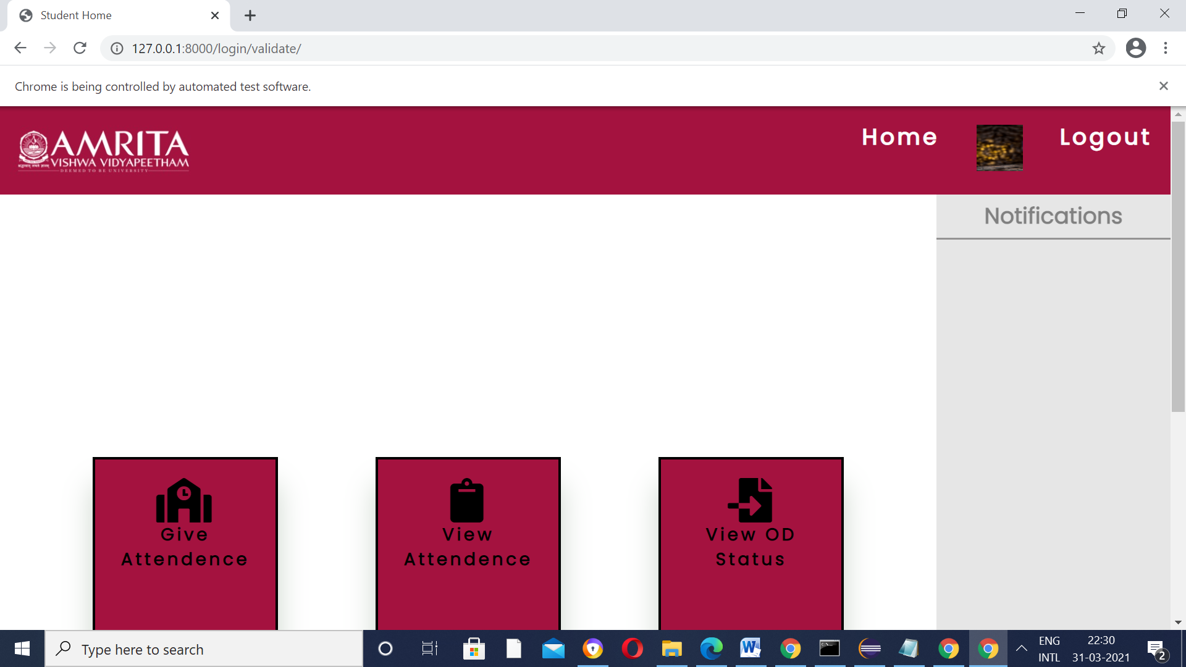

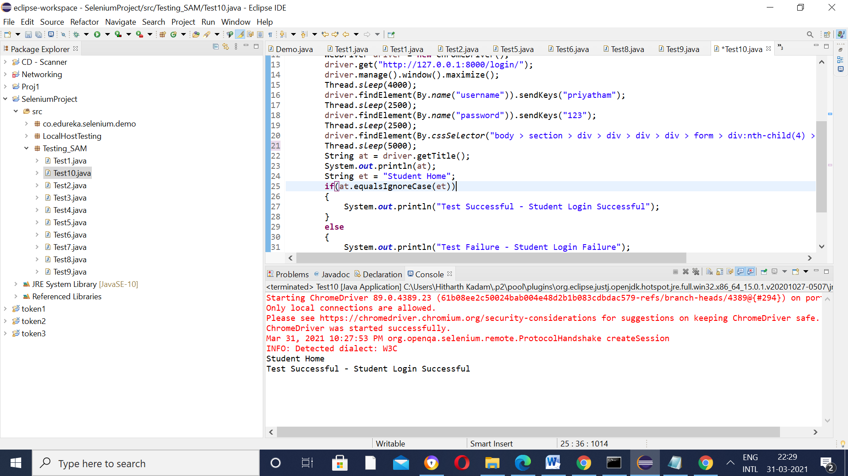

After UI/UX developers discussion,

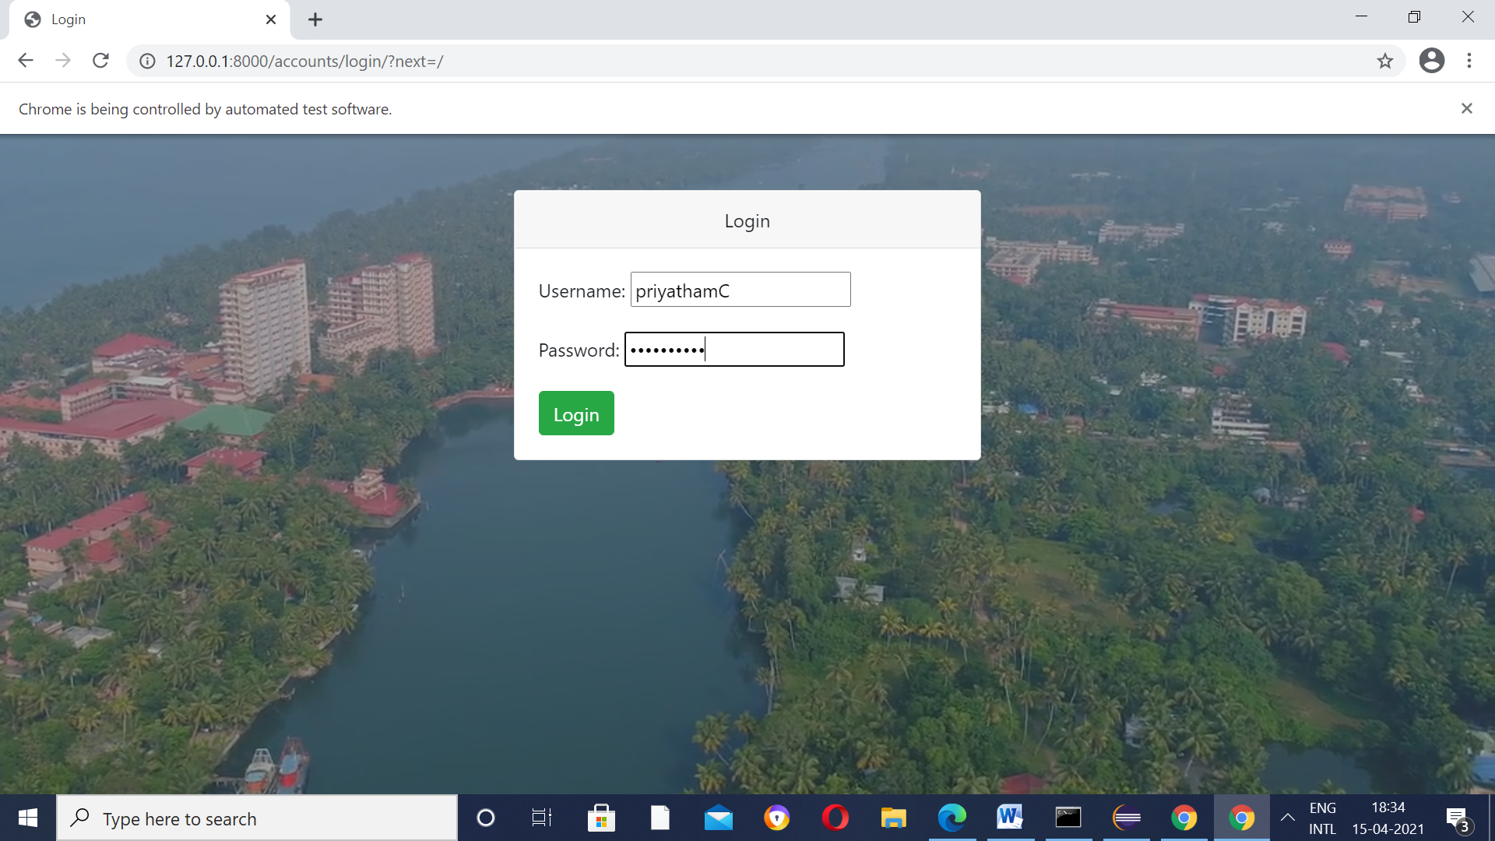

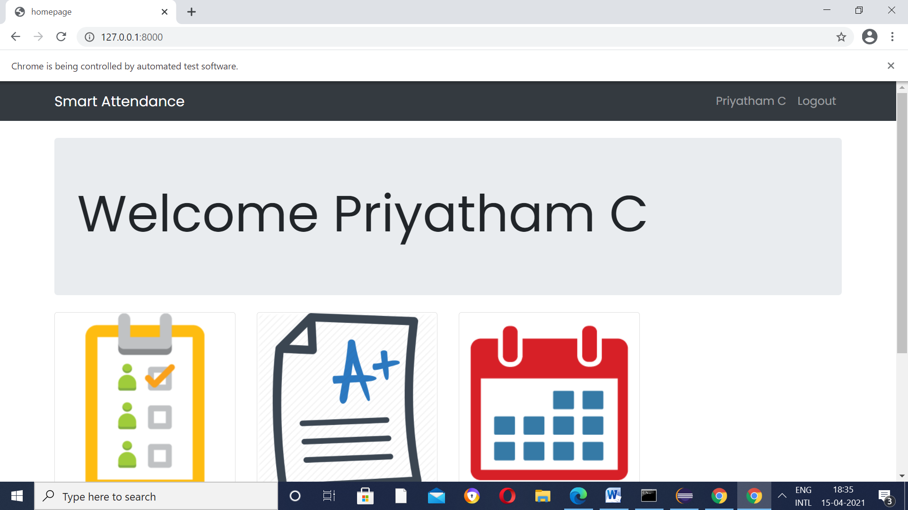

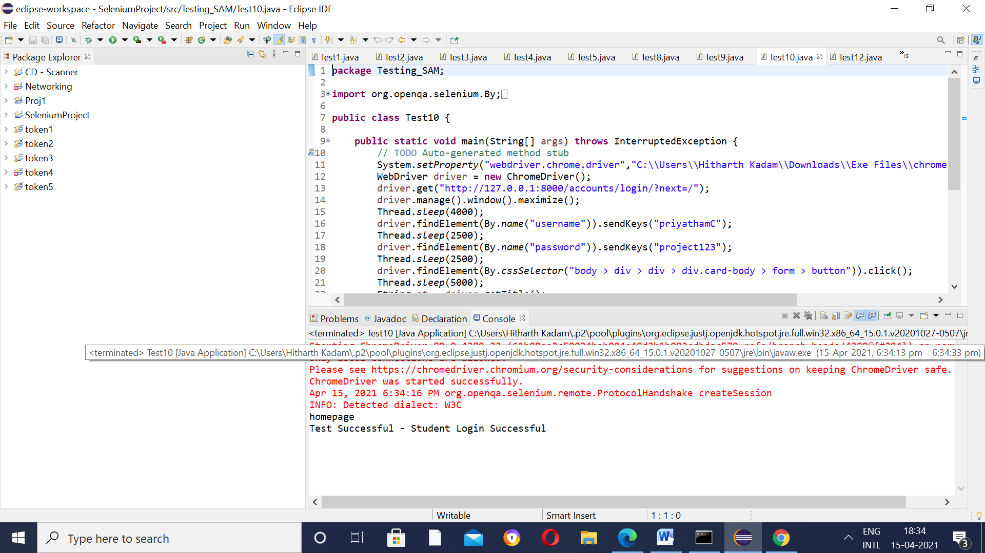

Test Case 11 – Test Login Page(for Student 2 - Hitharth)

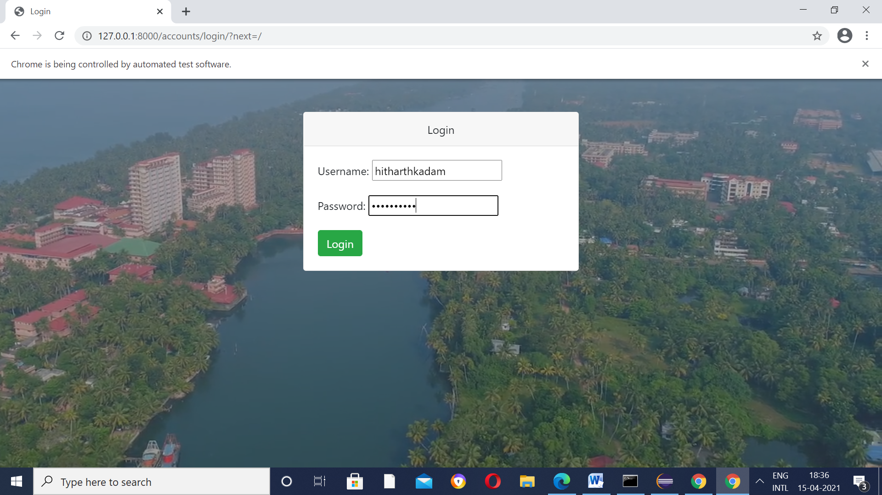

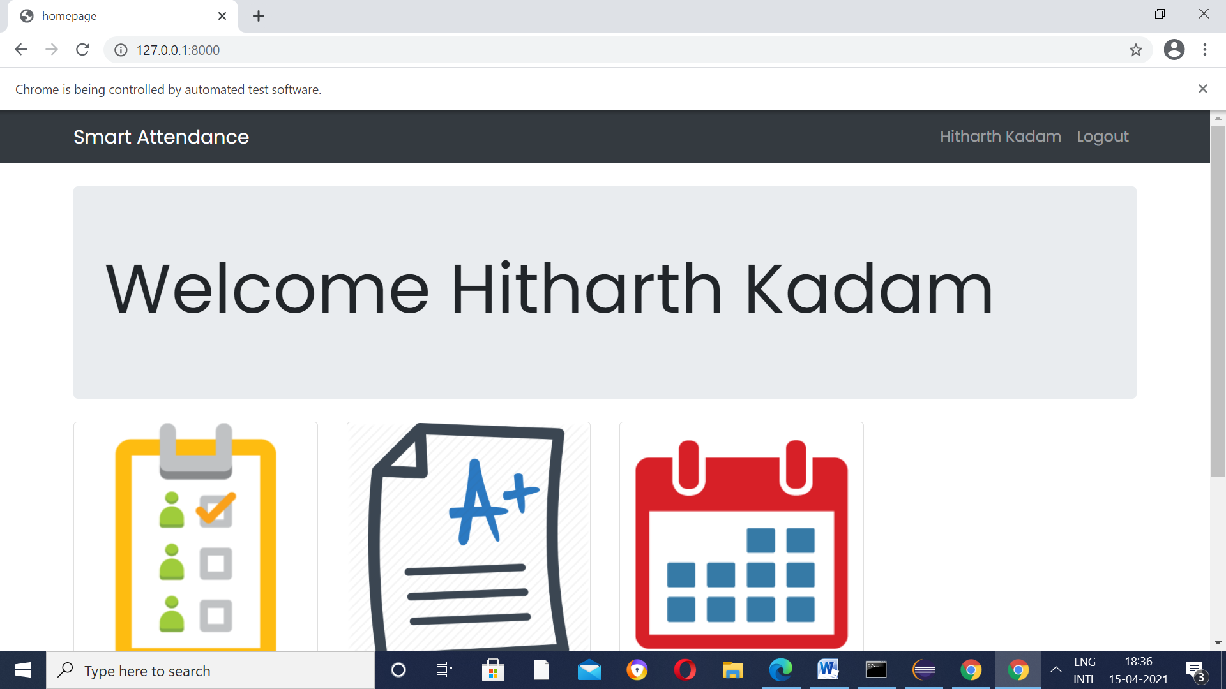

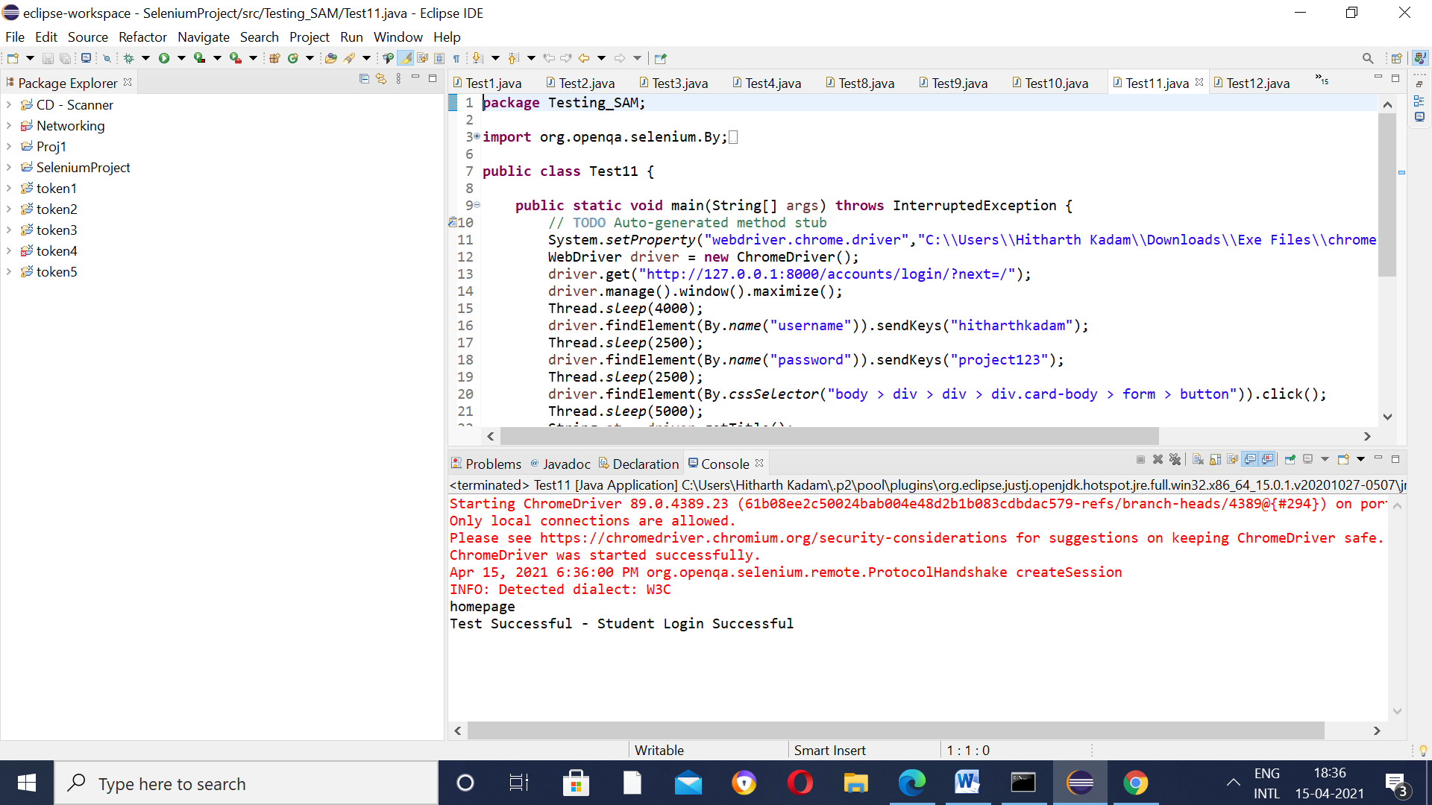

Test Case 12 - Test Login Page(for Student 3 - Akhila)

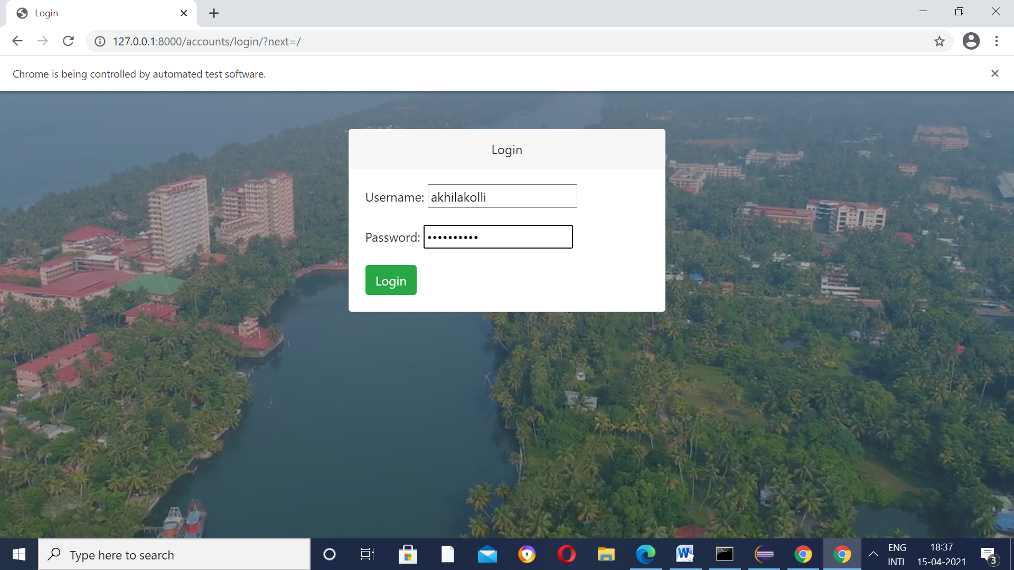

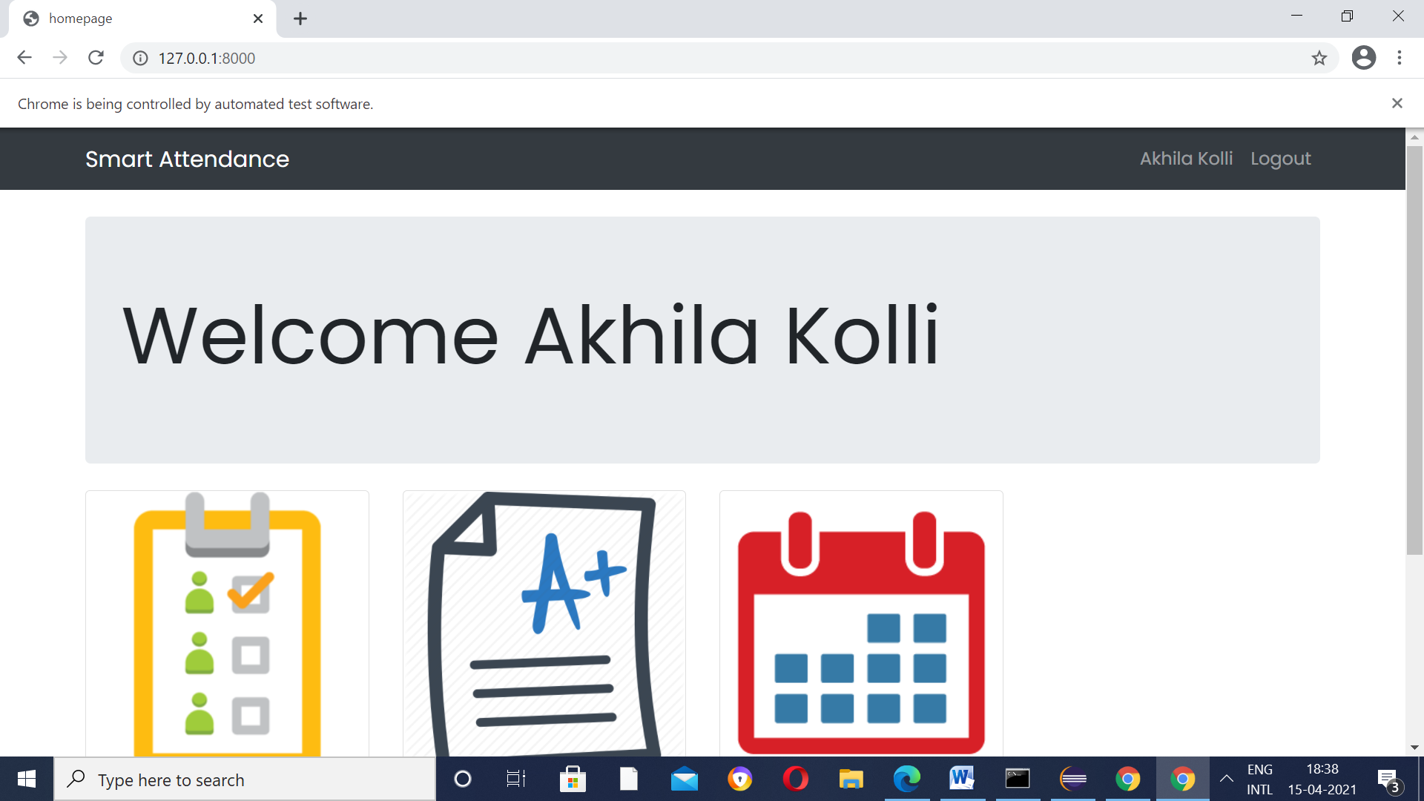

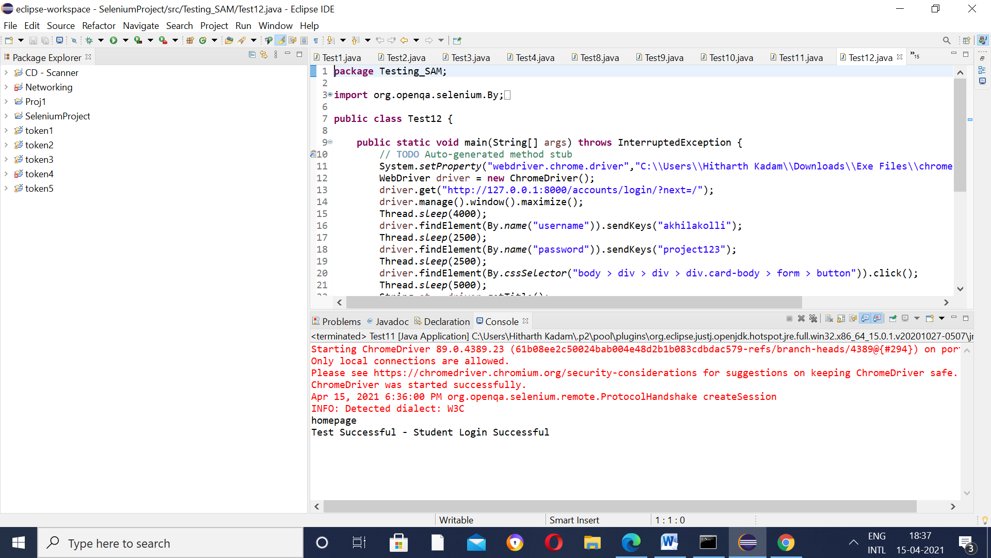

Test Case 13 - Test Login Page(for Student 3 - Shyam)

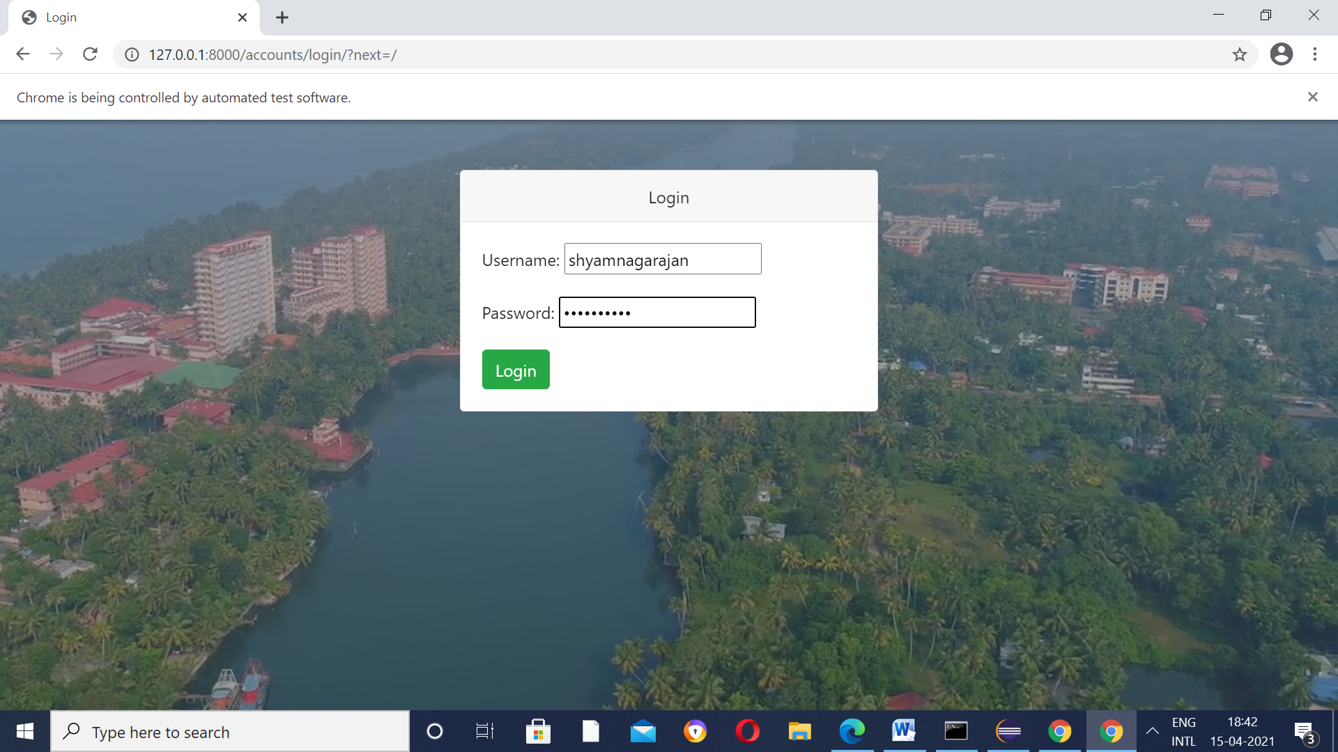

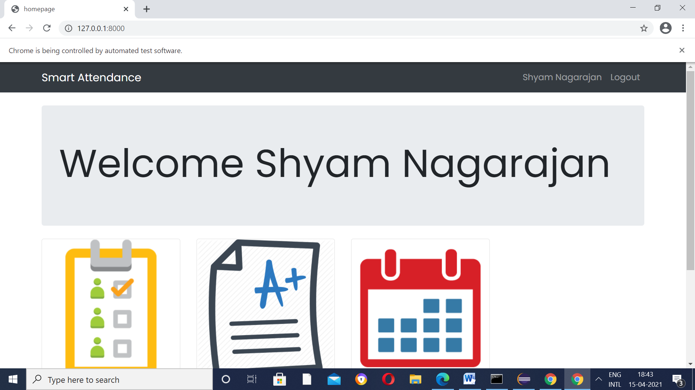

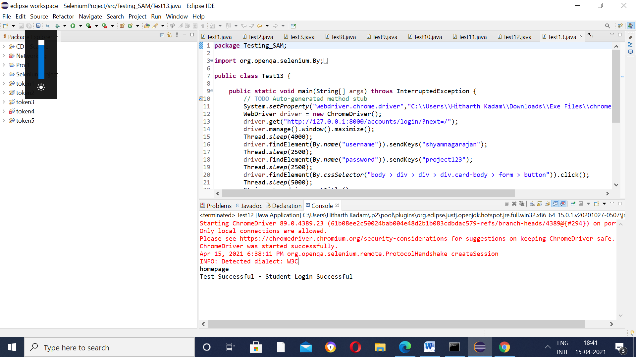

Test Case 14 - Test Login Page(for Student 3 - Hari)

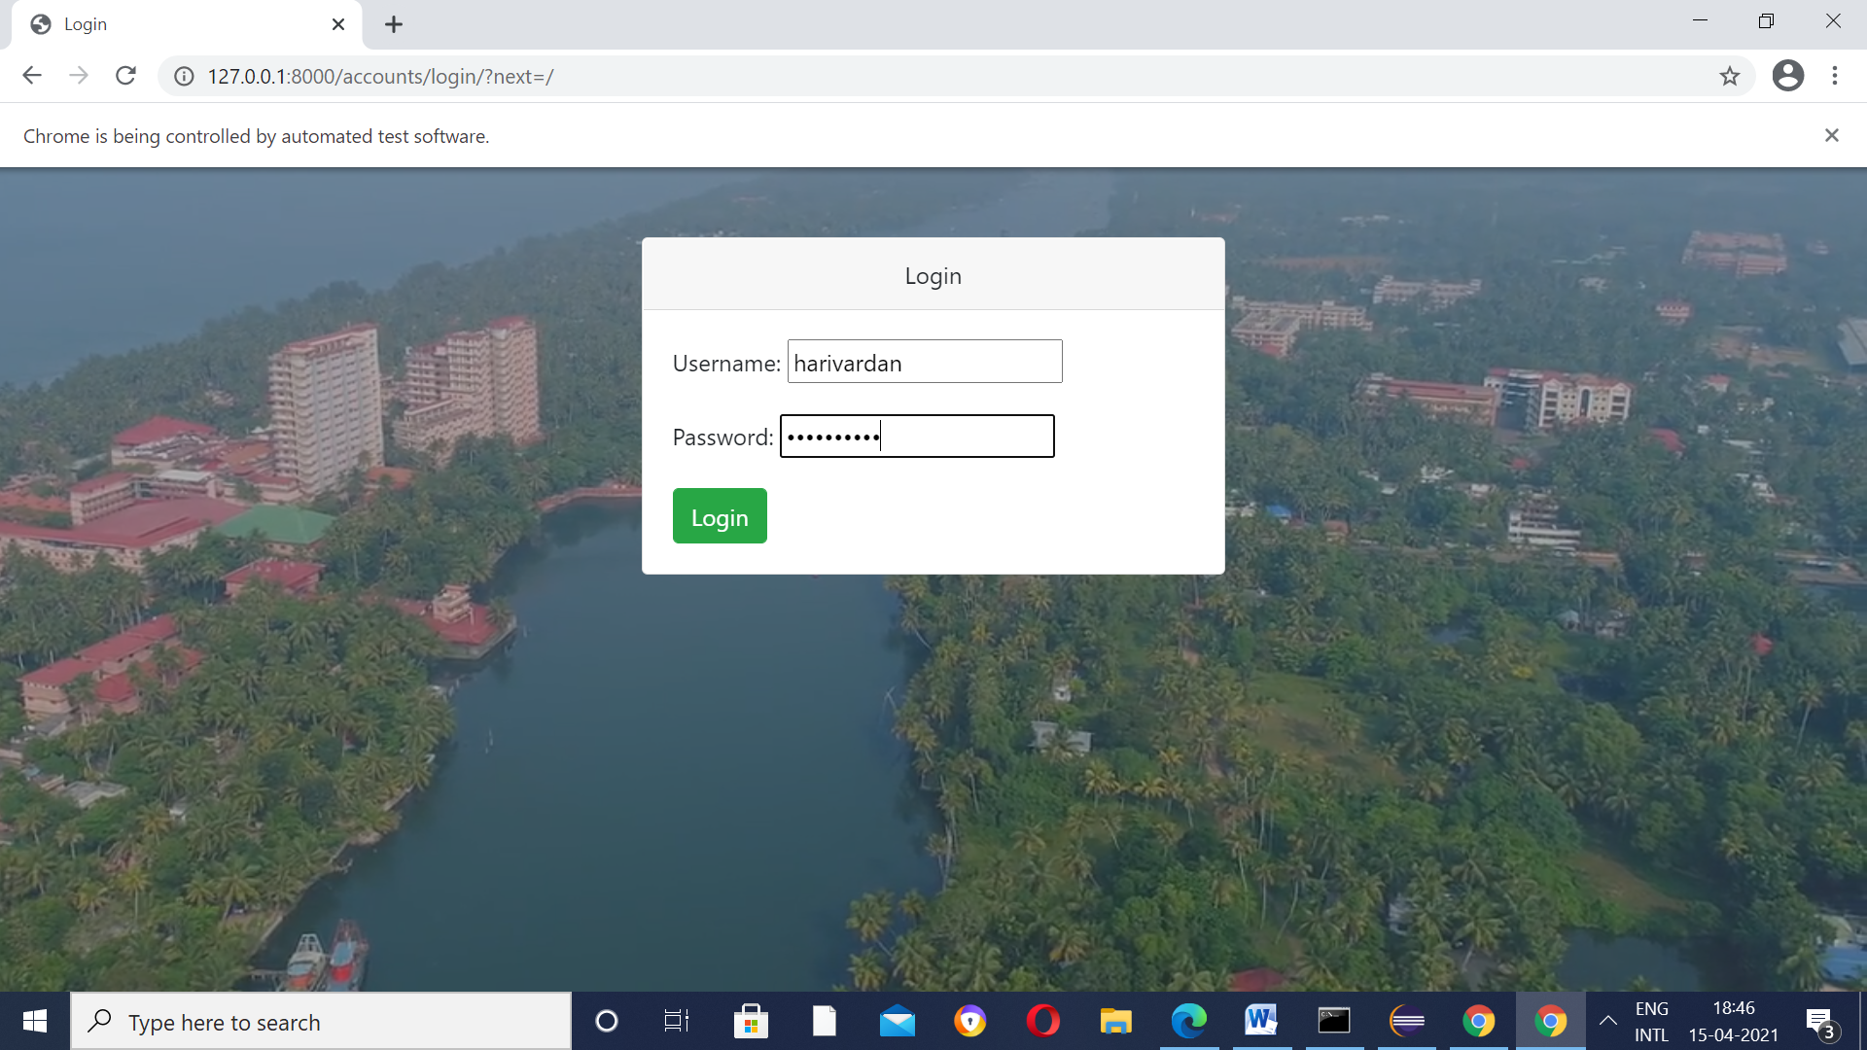

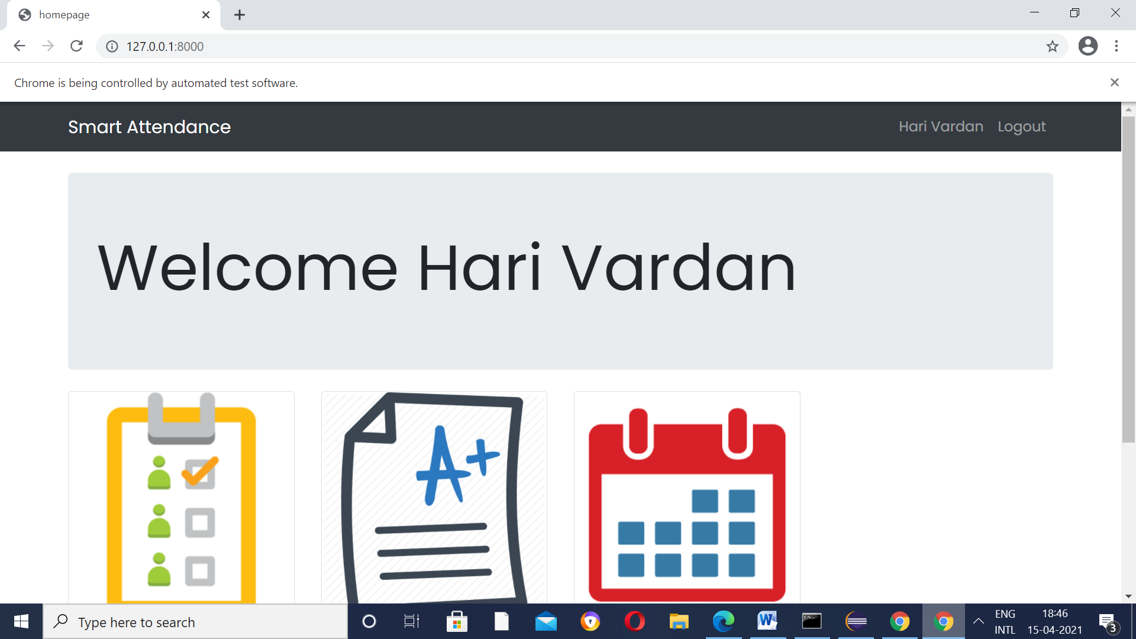

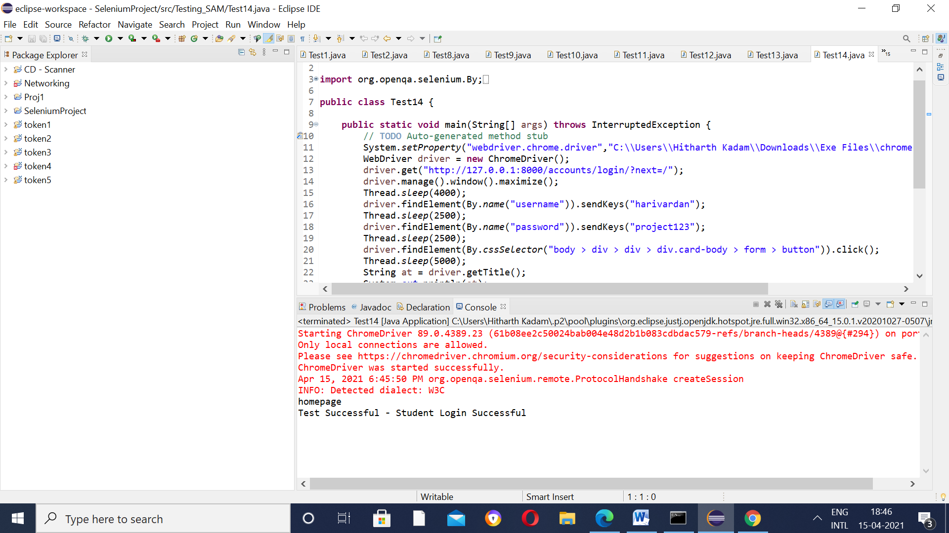

In testing, even if all the positive test cases, it is not considered a complete success.

To ensure 100% testing,we have to ensure that no negative test cases pass .

Test Case 15 – Test Incorrect Credentials - Change username (example harivardhan – Harivardhan) keep password same

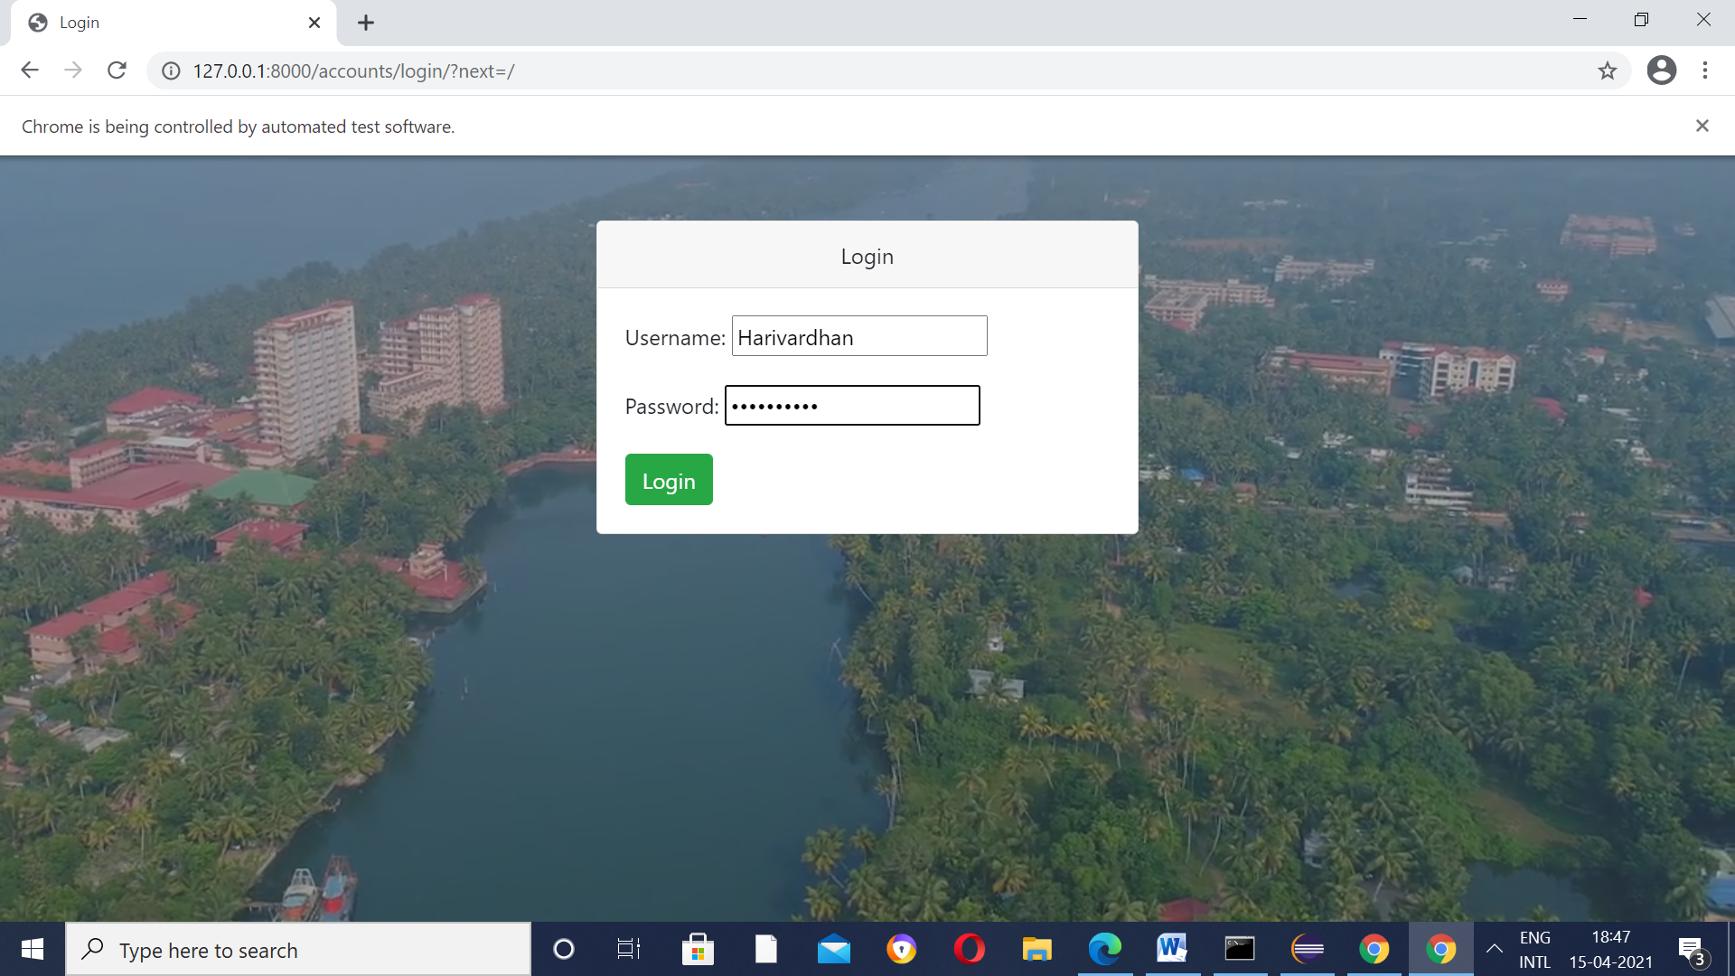

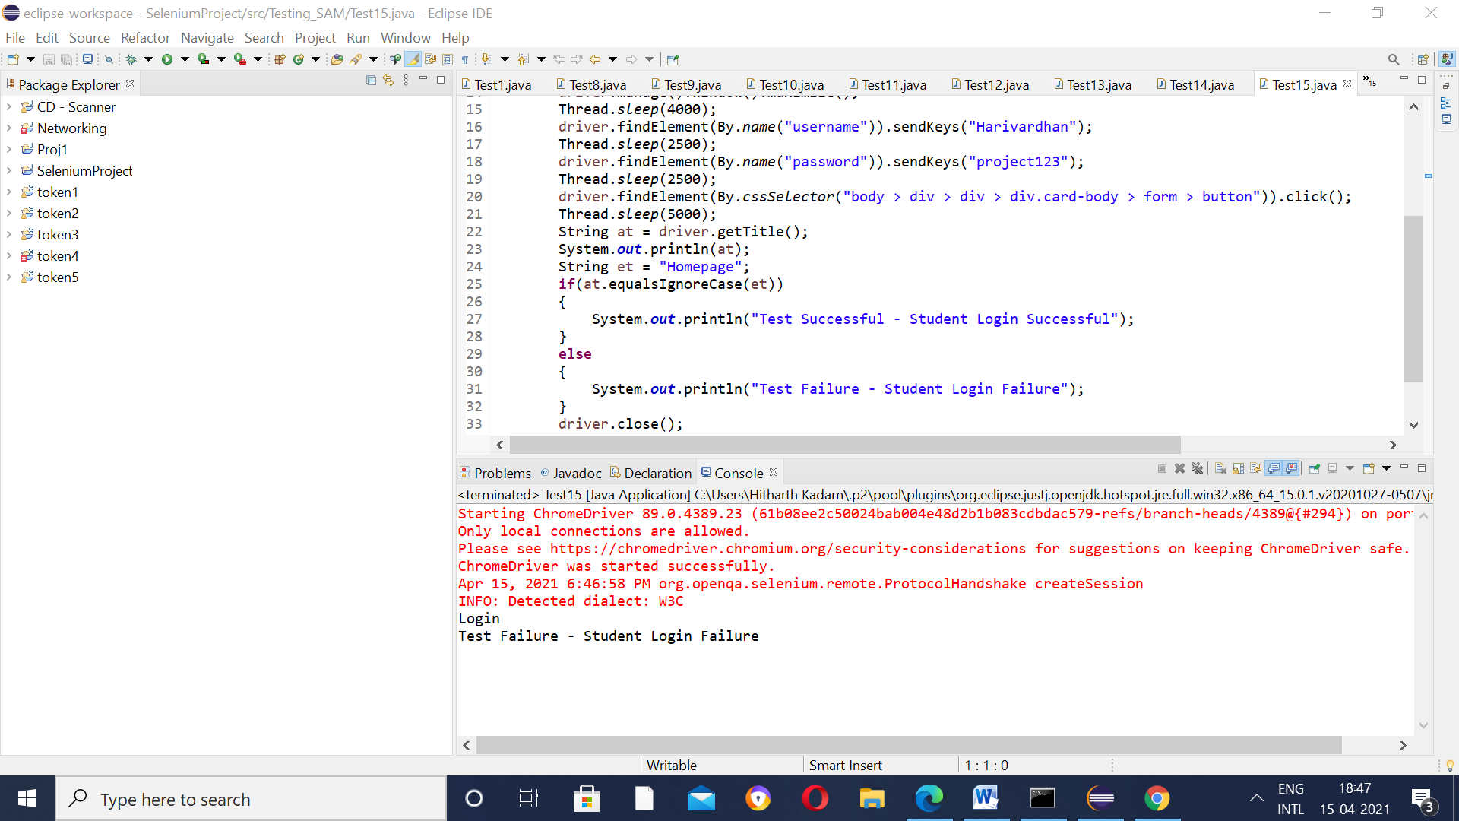

Please note here –

The above Test Case fails but logically this is the answer we are looking for.Why?

If you look closely, the test case is comparing the Title of the page(after giving the incorrect credentials) with the Student Home page(as we have seen before, the user is only directed to this page if he/she has provided the correct student credentials).

Previously,

As you may have guessed it, on entering the incorrect credentials , the user is redirected to an ERROR page(which is shown below).Since,these 2 pages are different, the aforementioned Test Case fails.

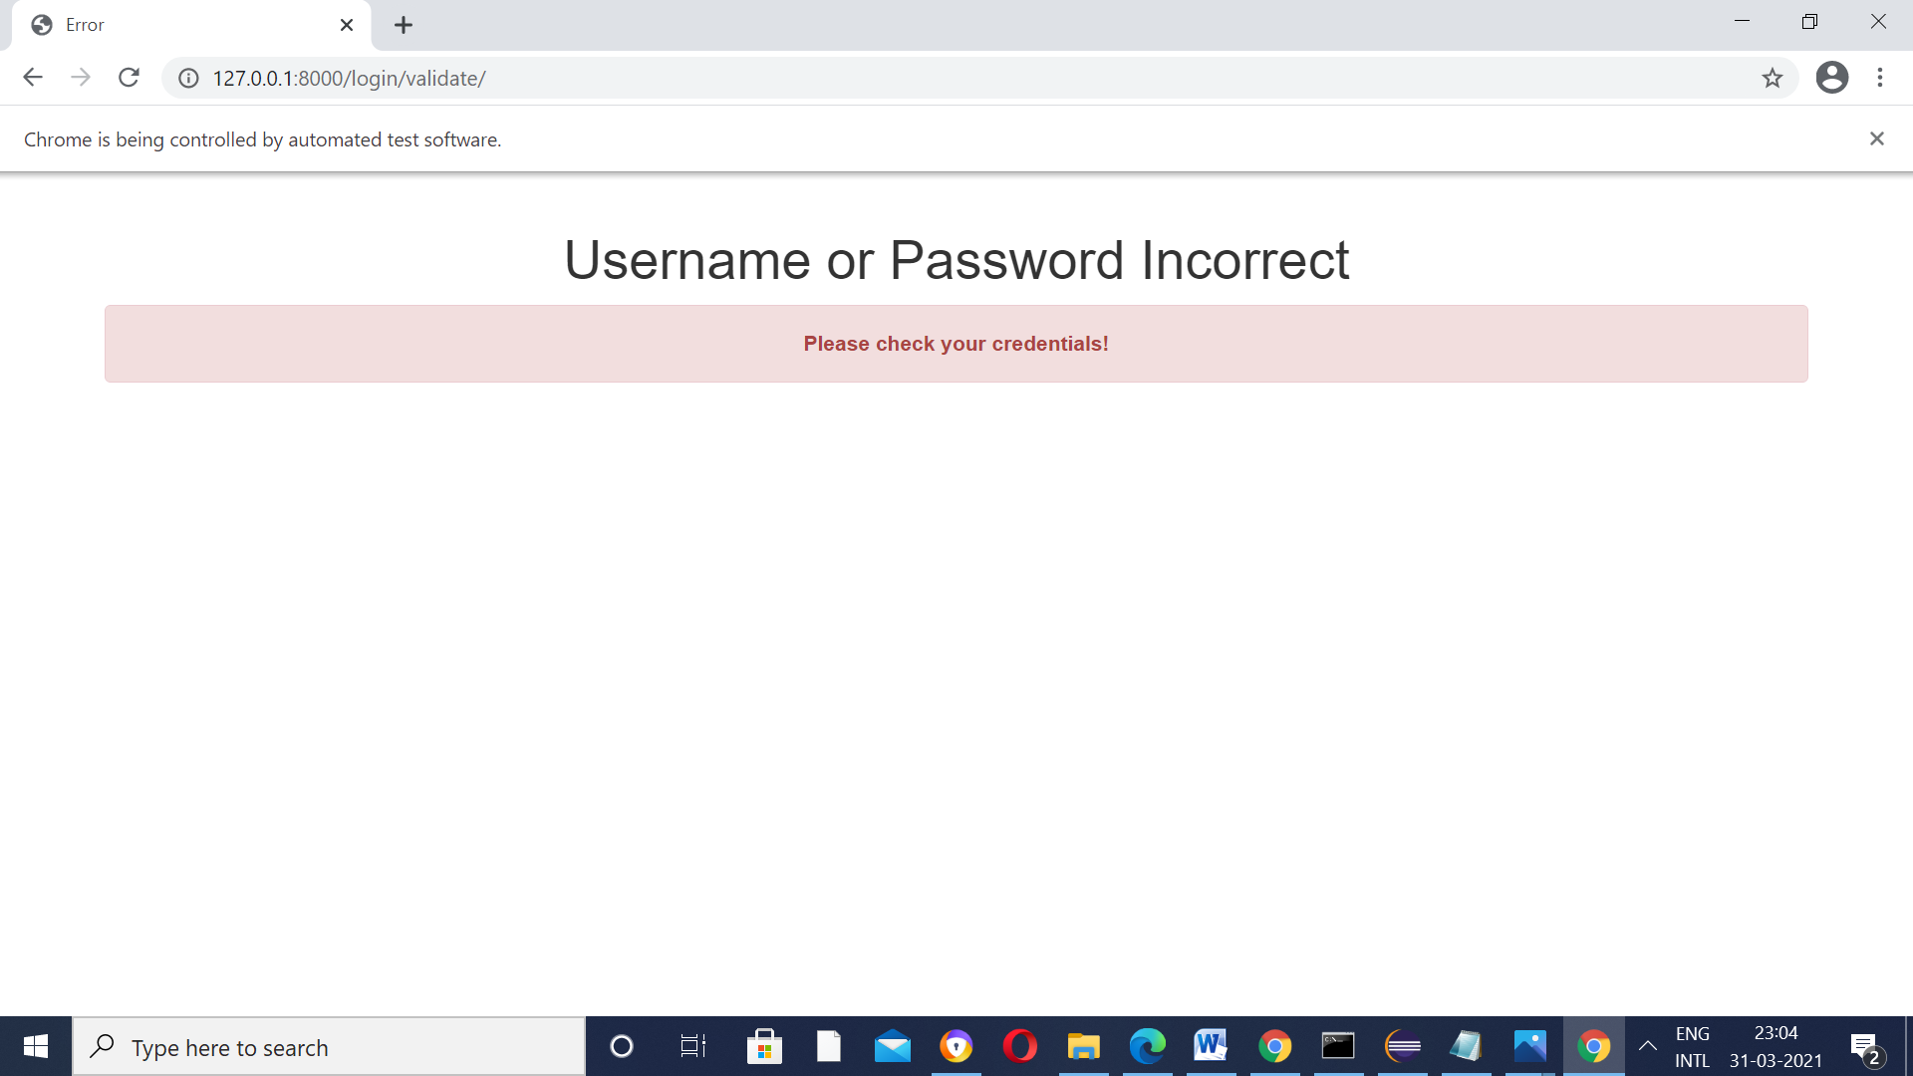

And now,

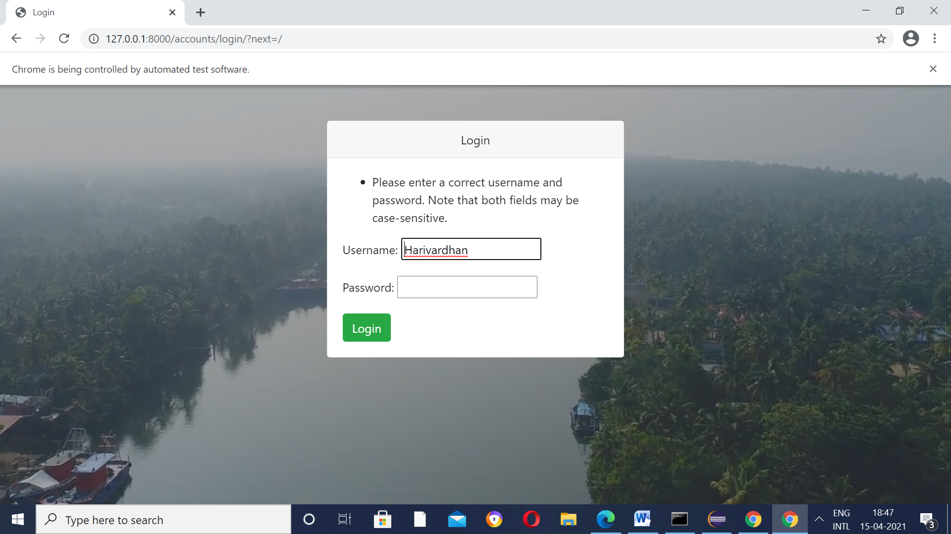

To ensure efficiency and better user experience, the following change has been made.

Test Case 16 -

Test Incorrect Credentials - Change password(project123 – 12345) keep username same

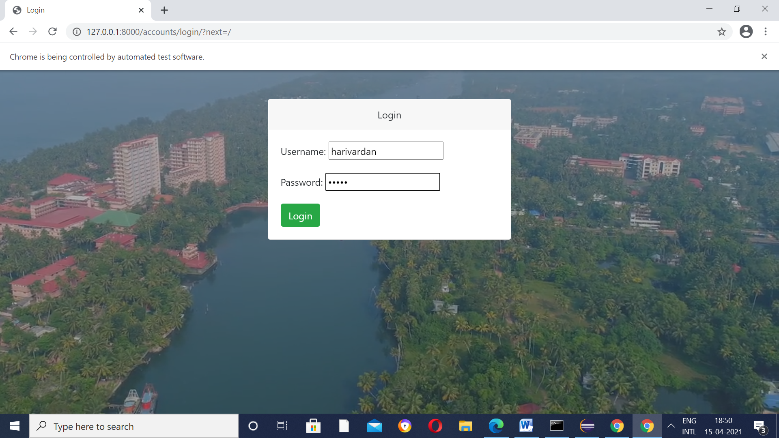

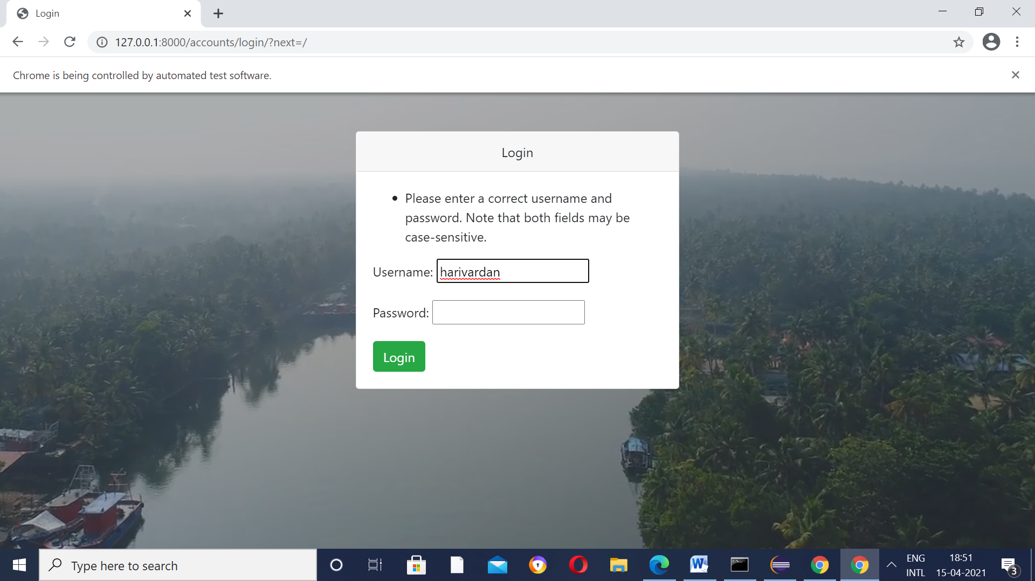

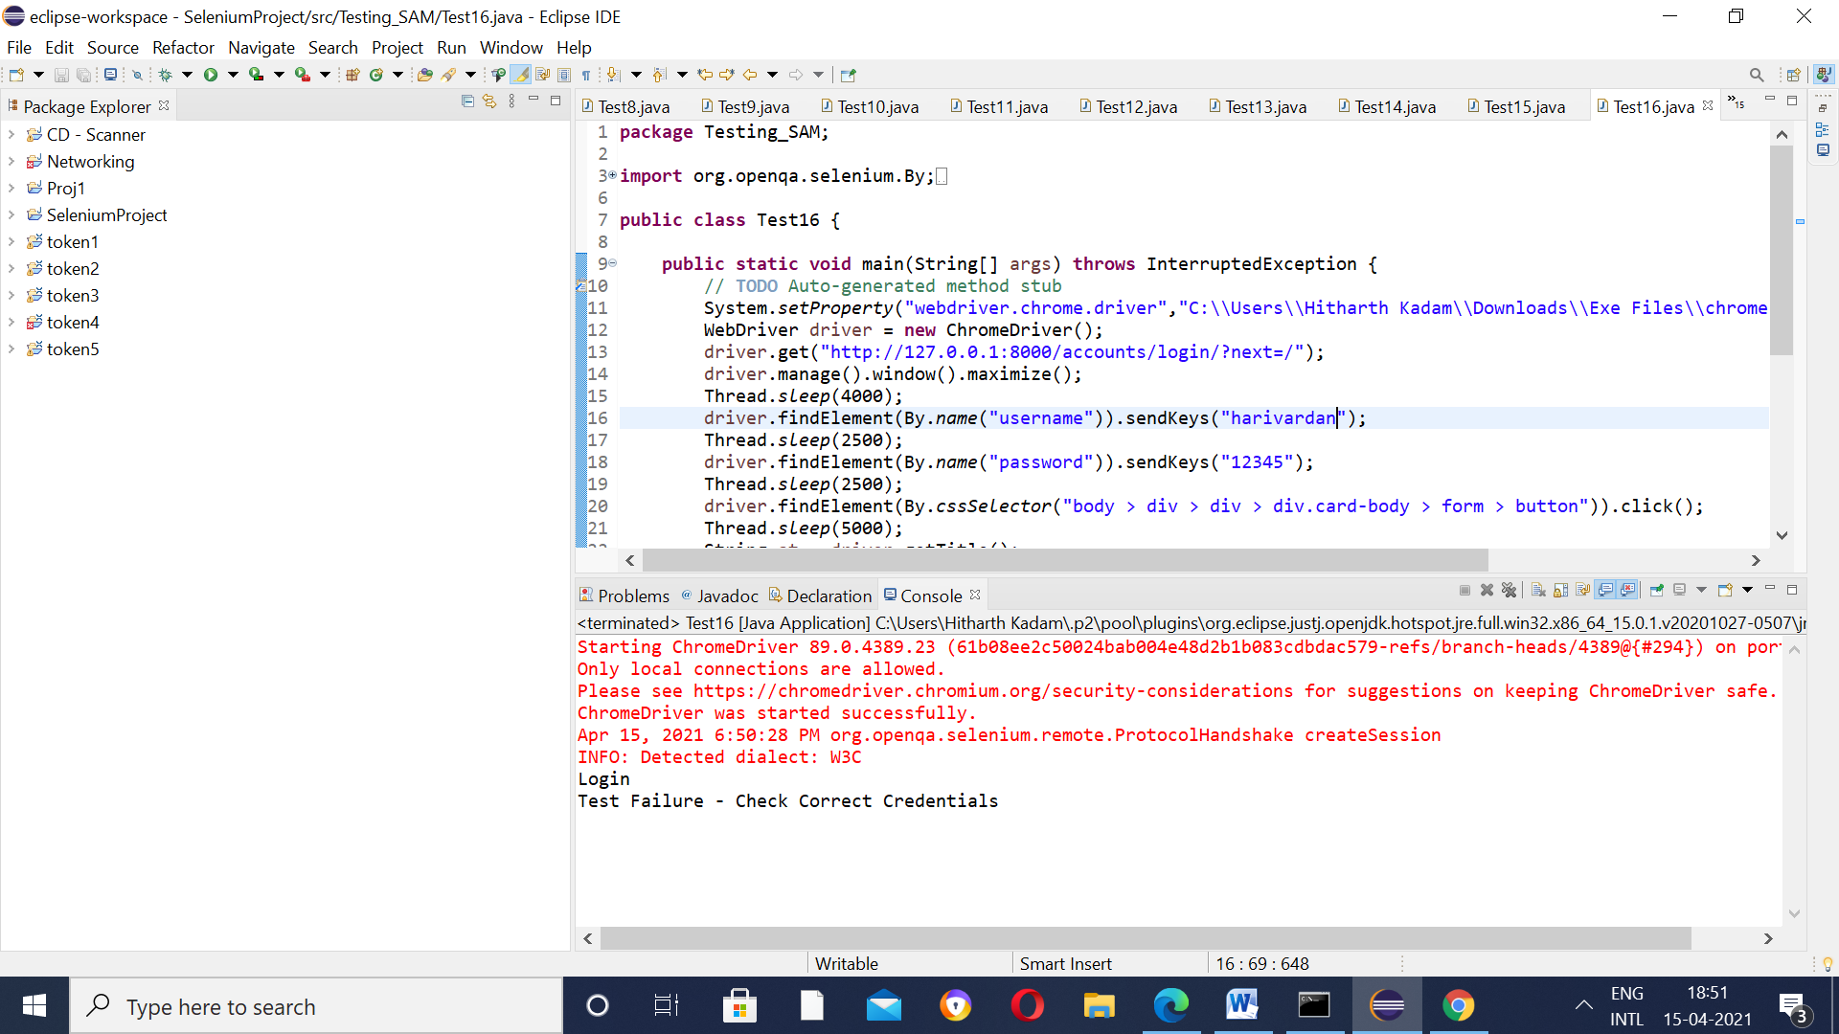

Test Case 17 – Test Login Page(for Teacher 1 - Trisila)

Previously,

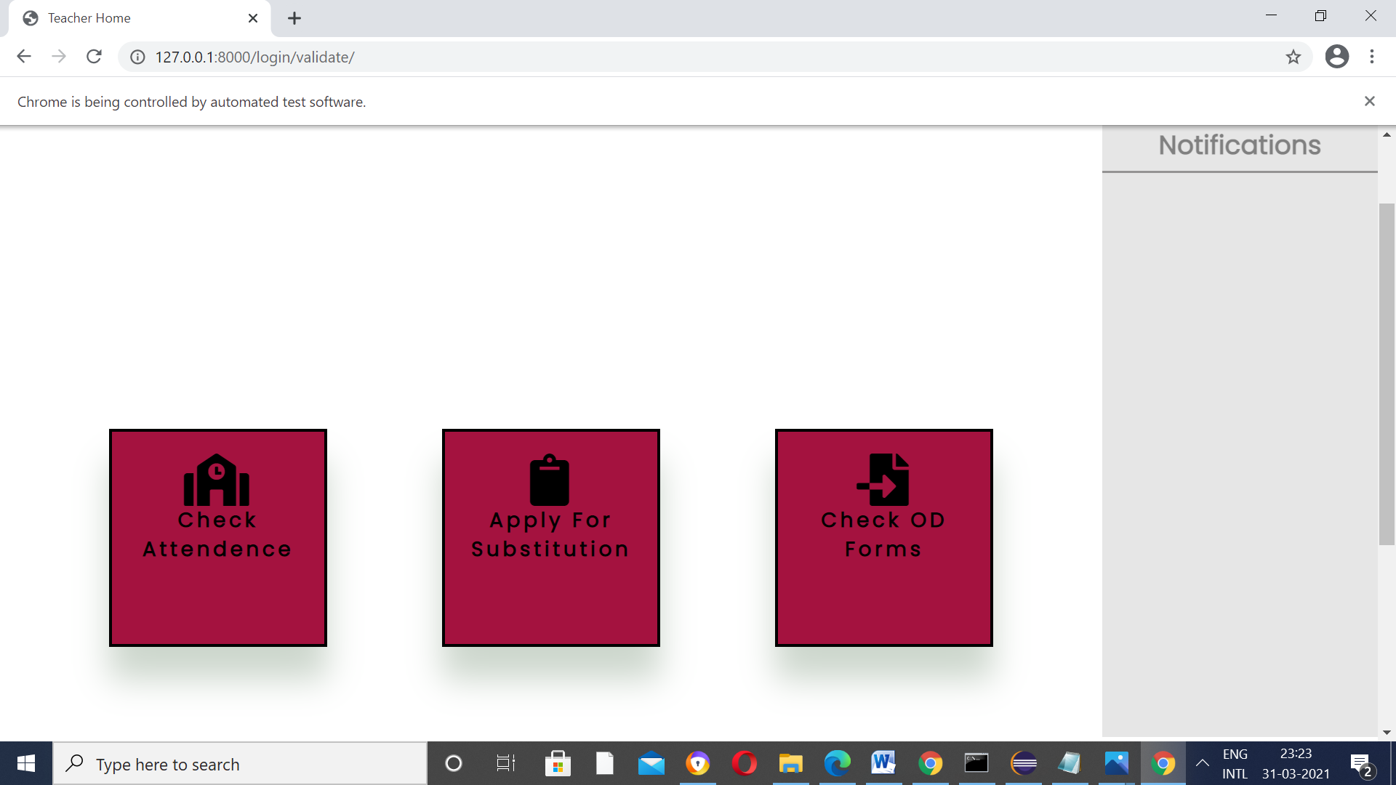

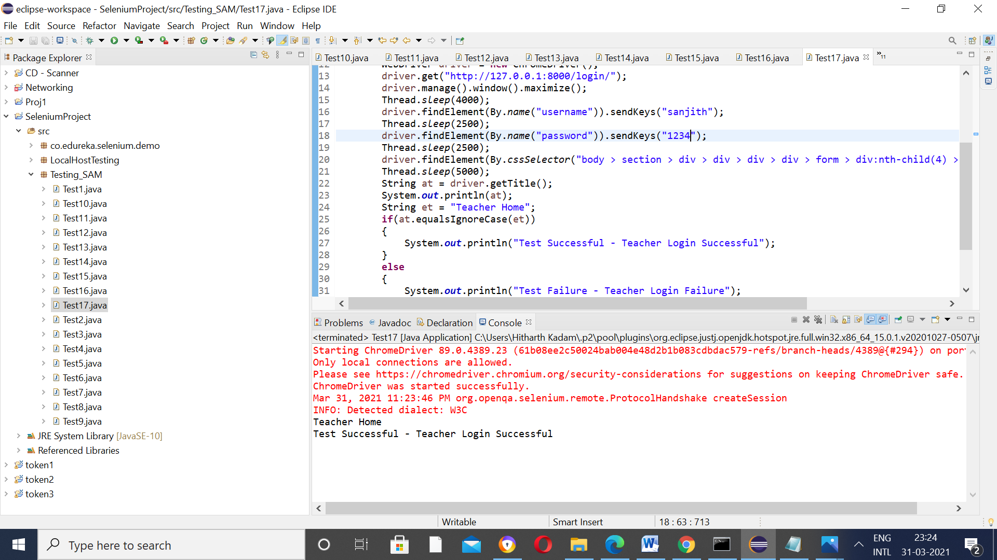

Now,

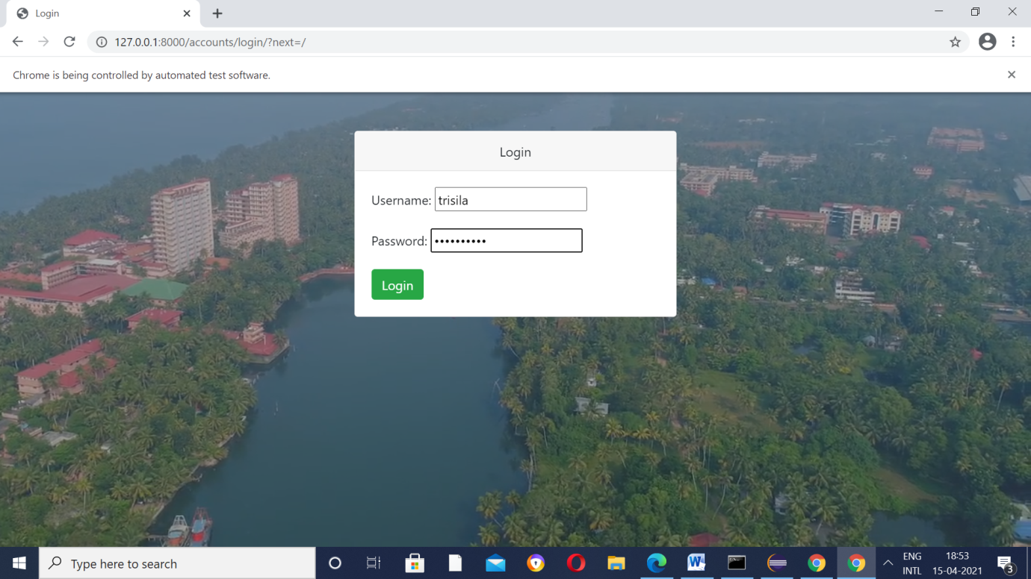

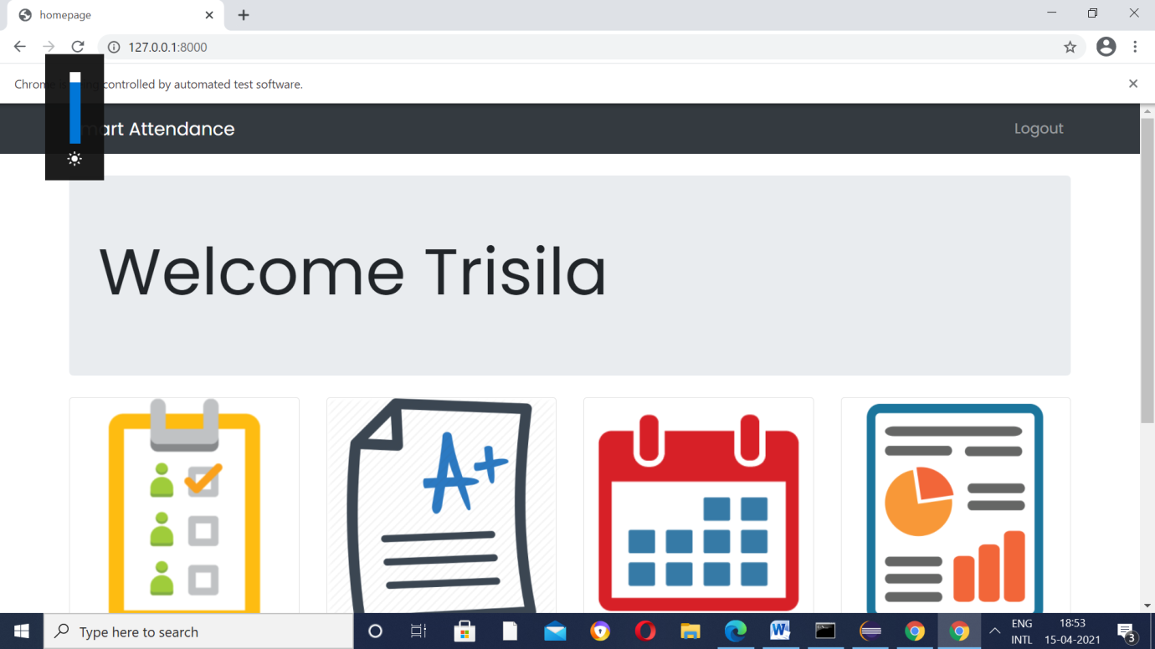

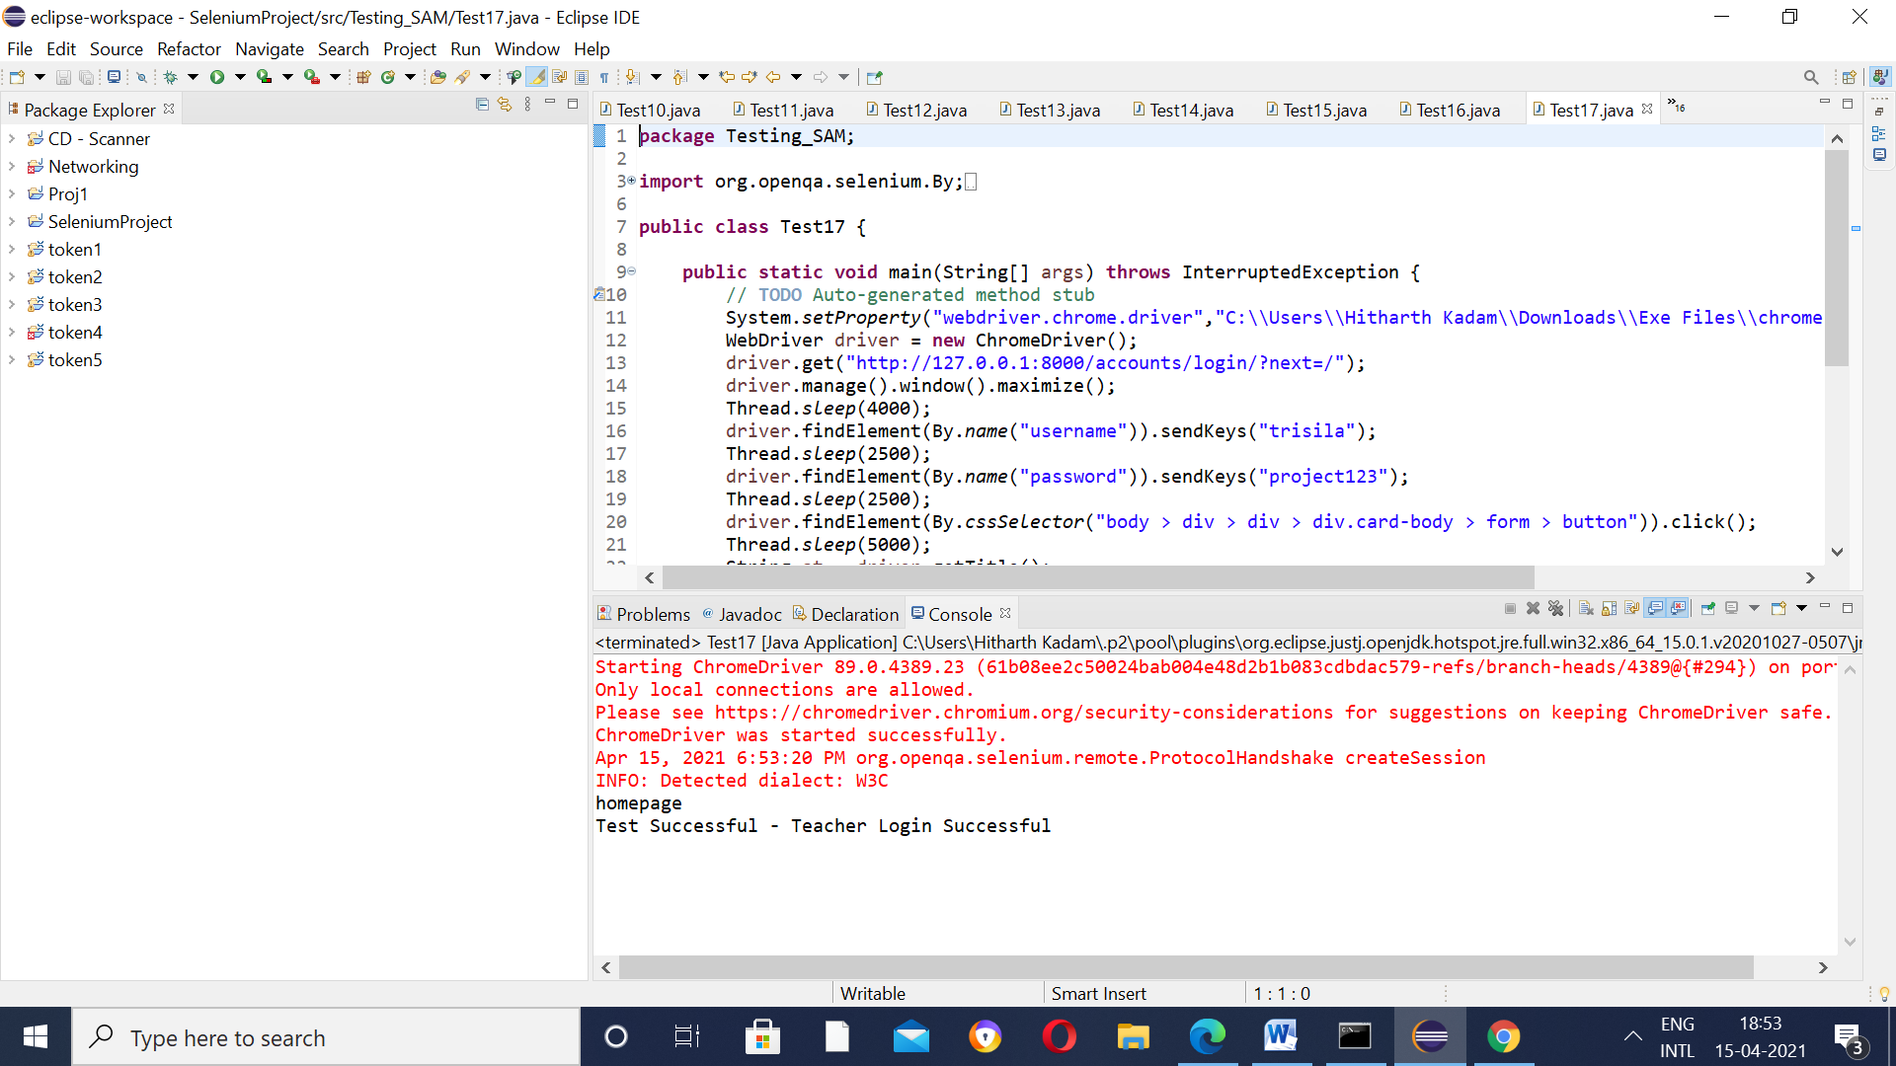

Test Case 18 – Provide Incorrect Credentials(Change username trisila– Tris) keep password same

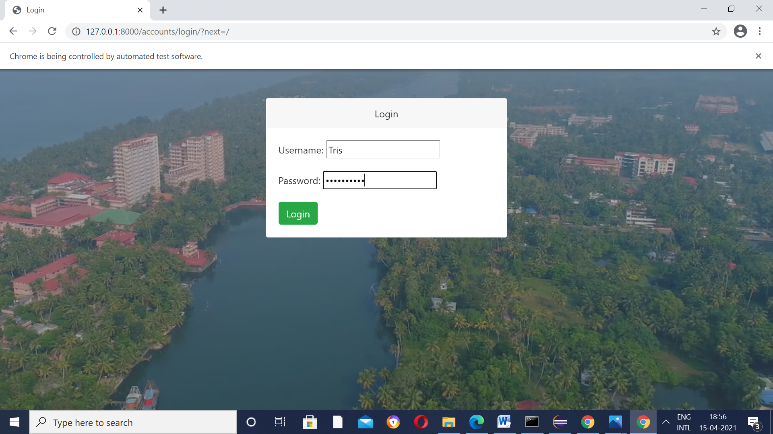

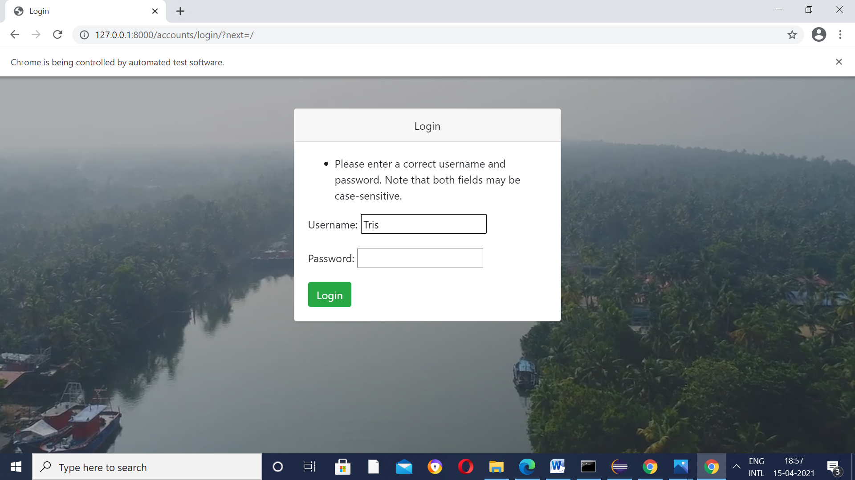

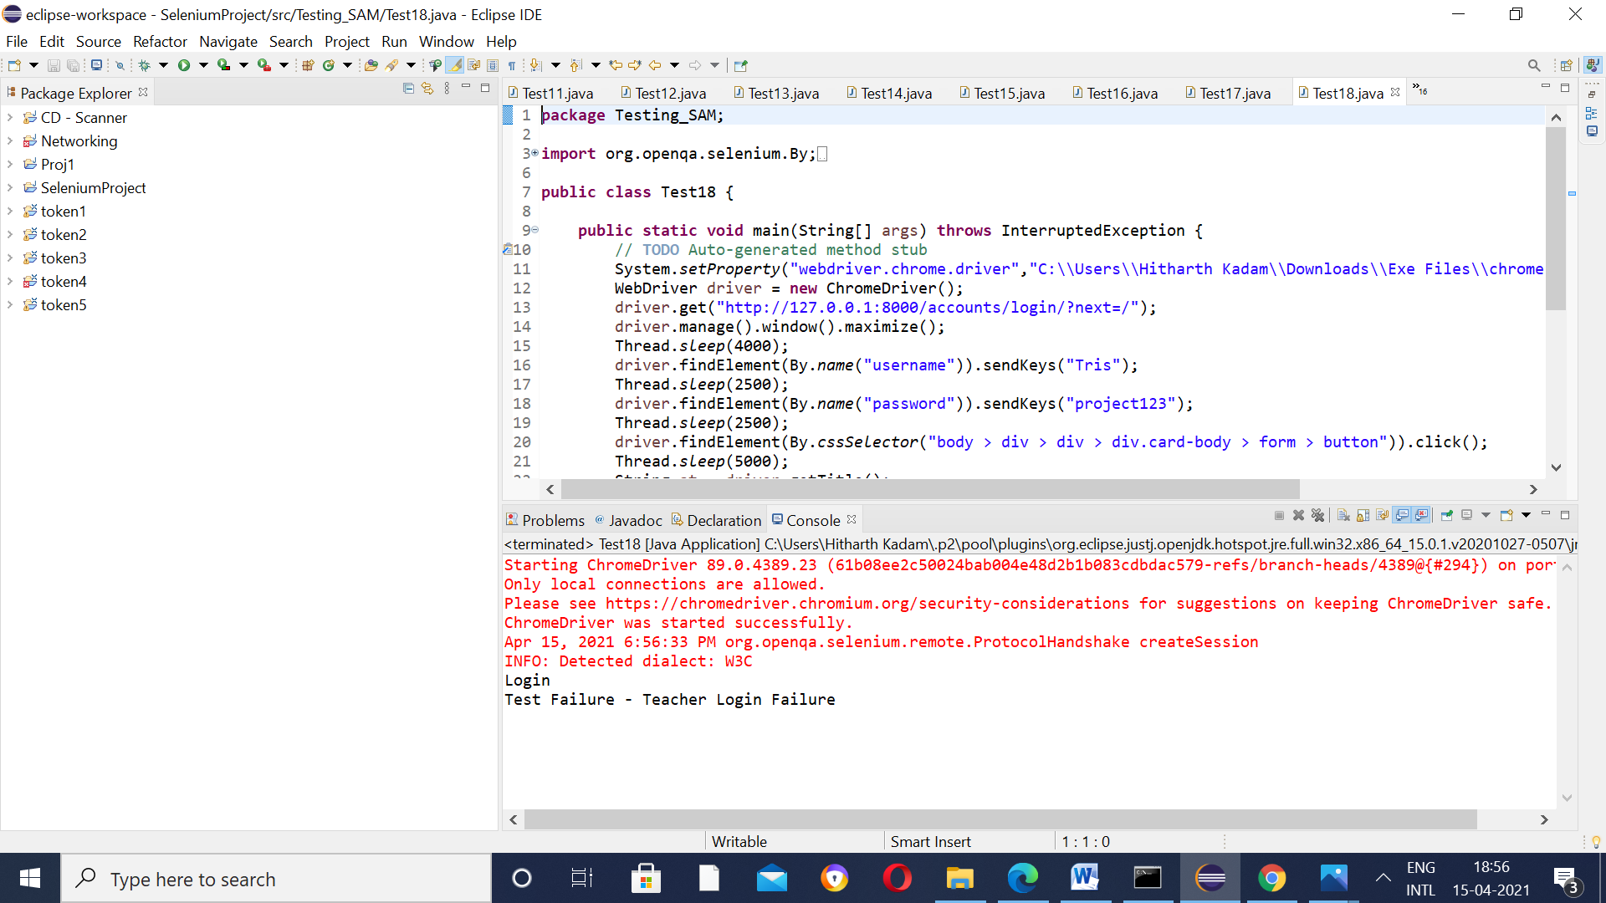

Test Case 19 – Provide Incorrect Credentials(Change password project123 - 12345) keep username

same

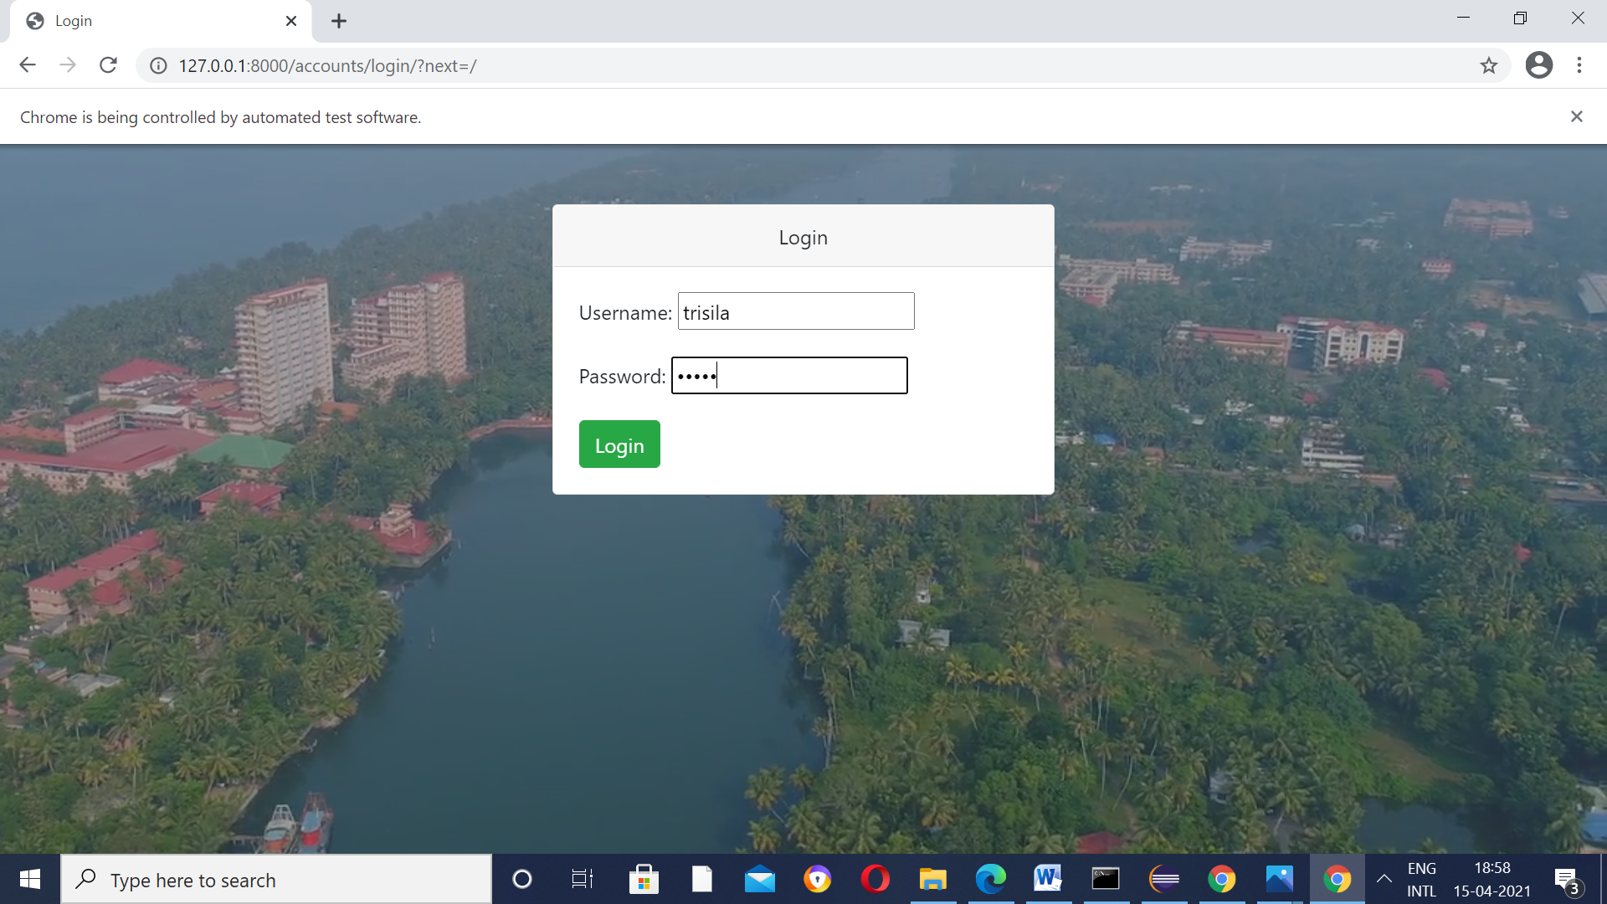

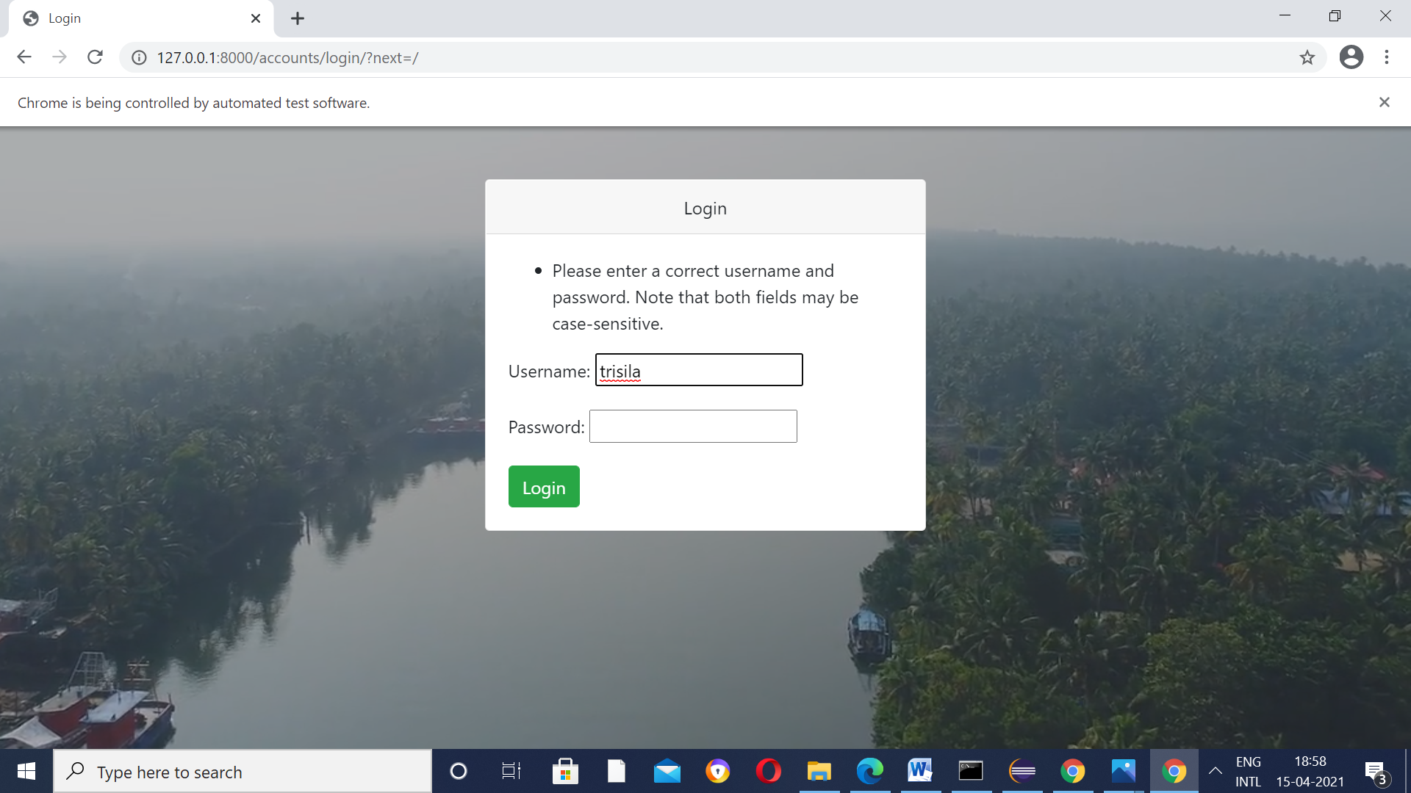

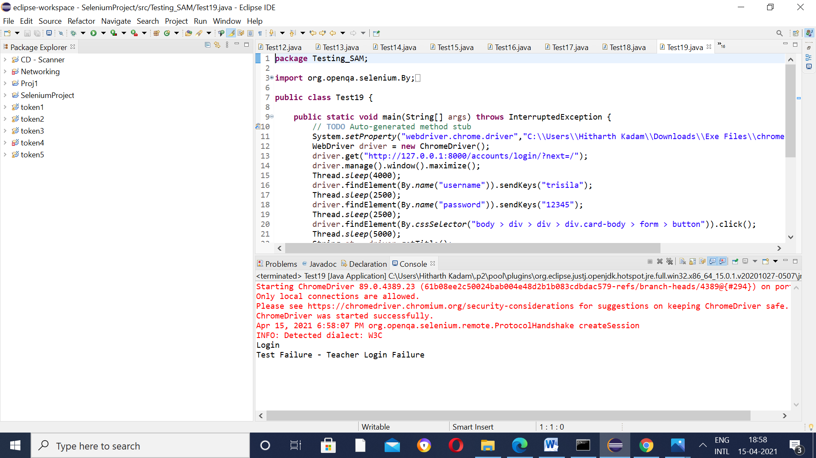

Test Case 20 – Provide Incorrect Credentials(Change both Username and Password)

(Though we know the validation of Username and Password is an AND mechanism)

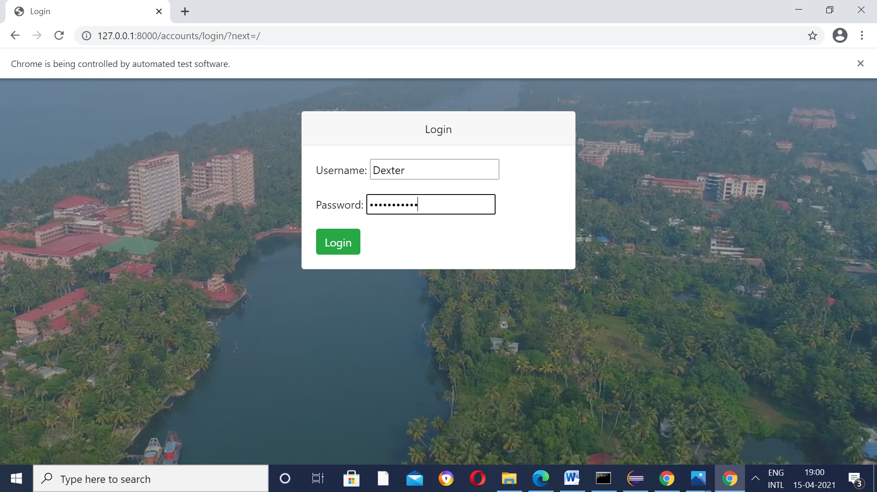

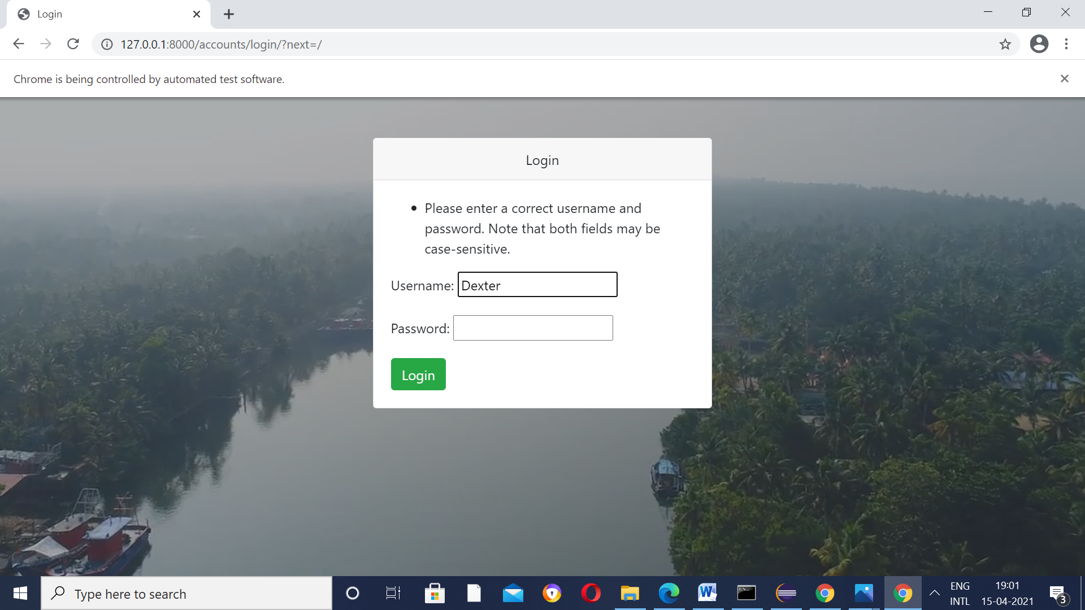

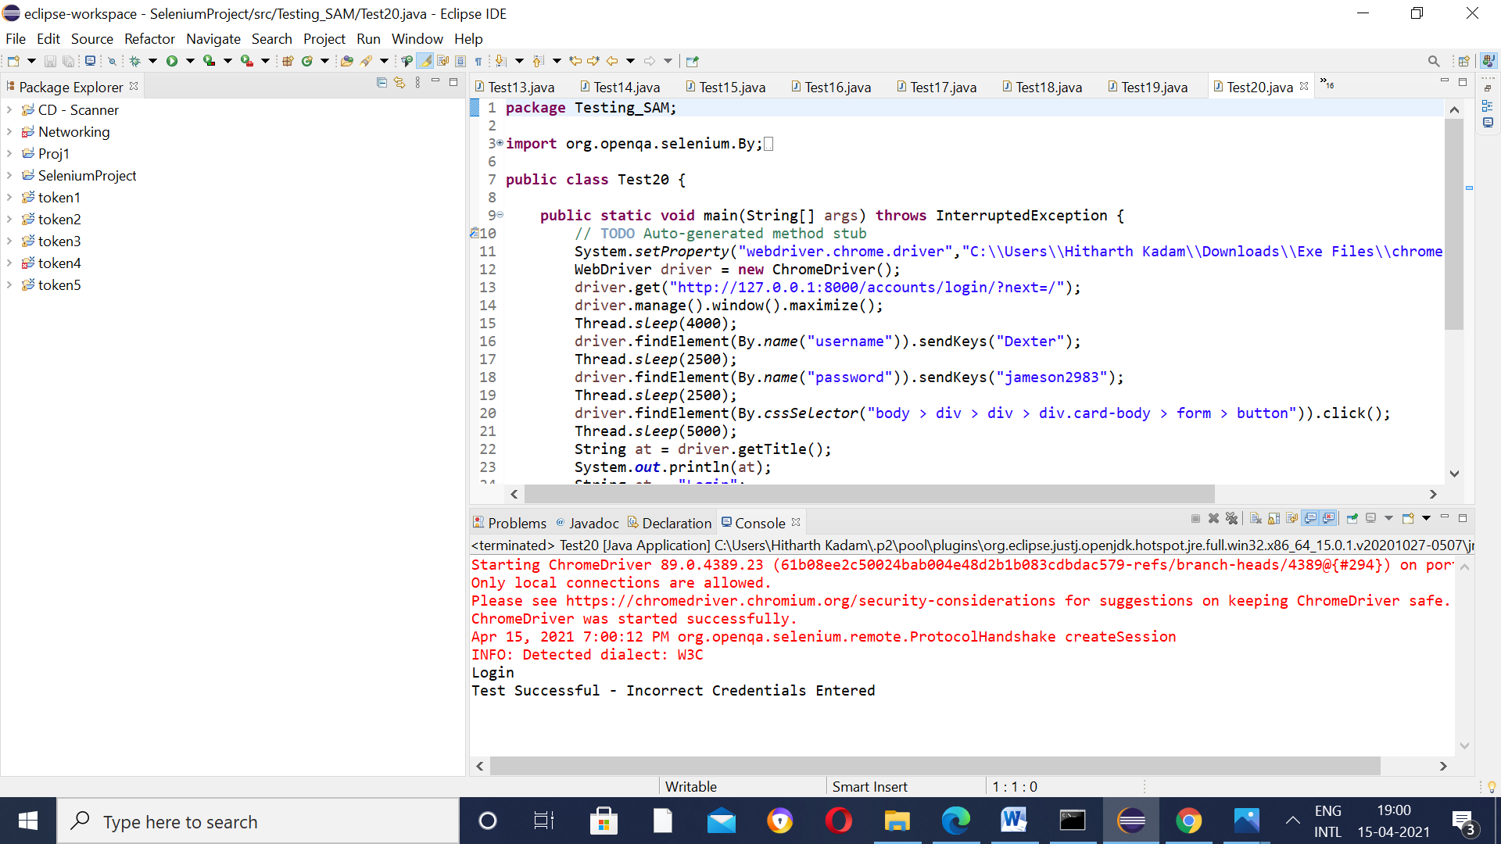

Test Case 21 – Check Navigation from About Page

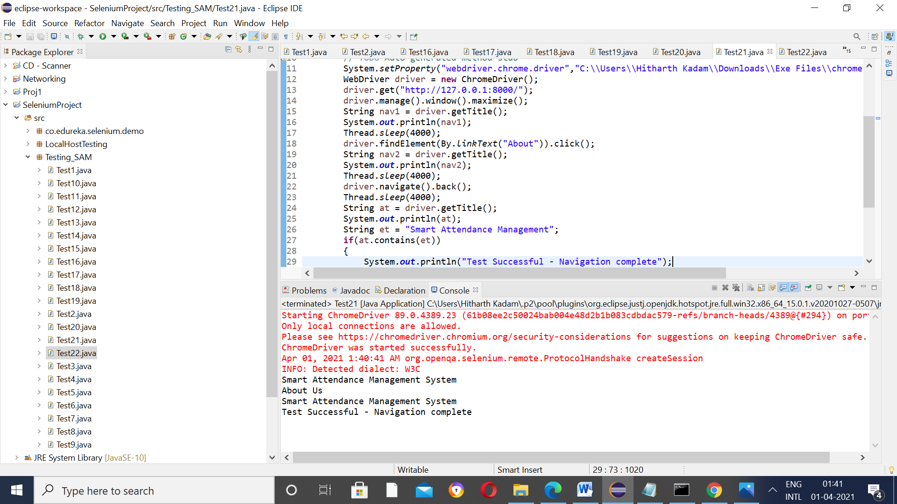

Test Case 22 – Check Navigation from the Contact Us Page

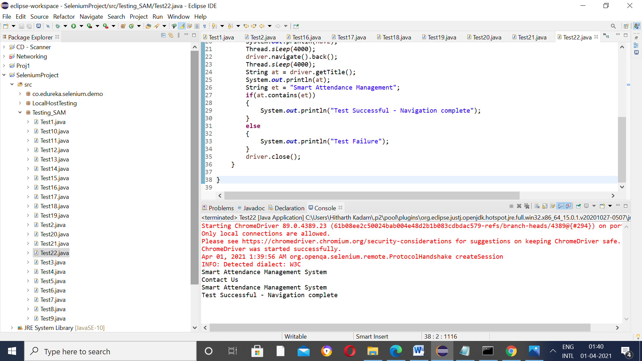

Test Case 23 – Check Navigation from the Calendar Page

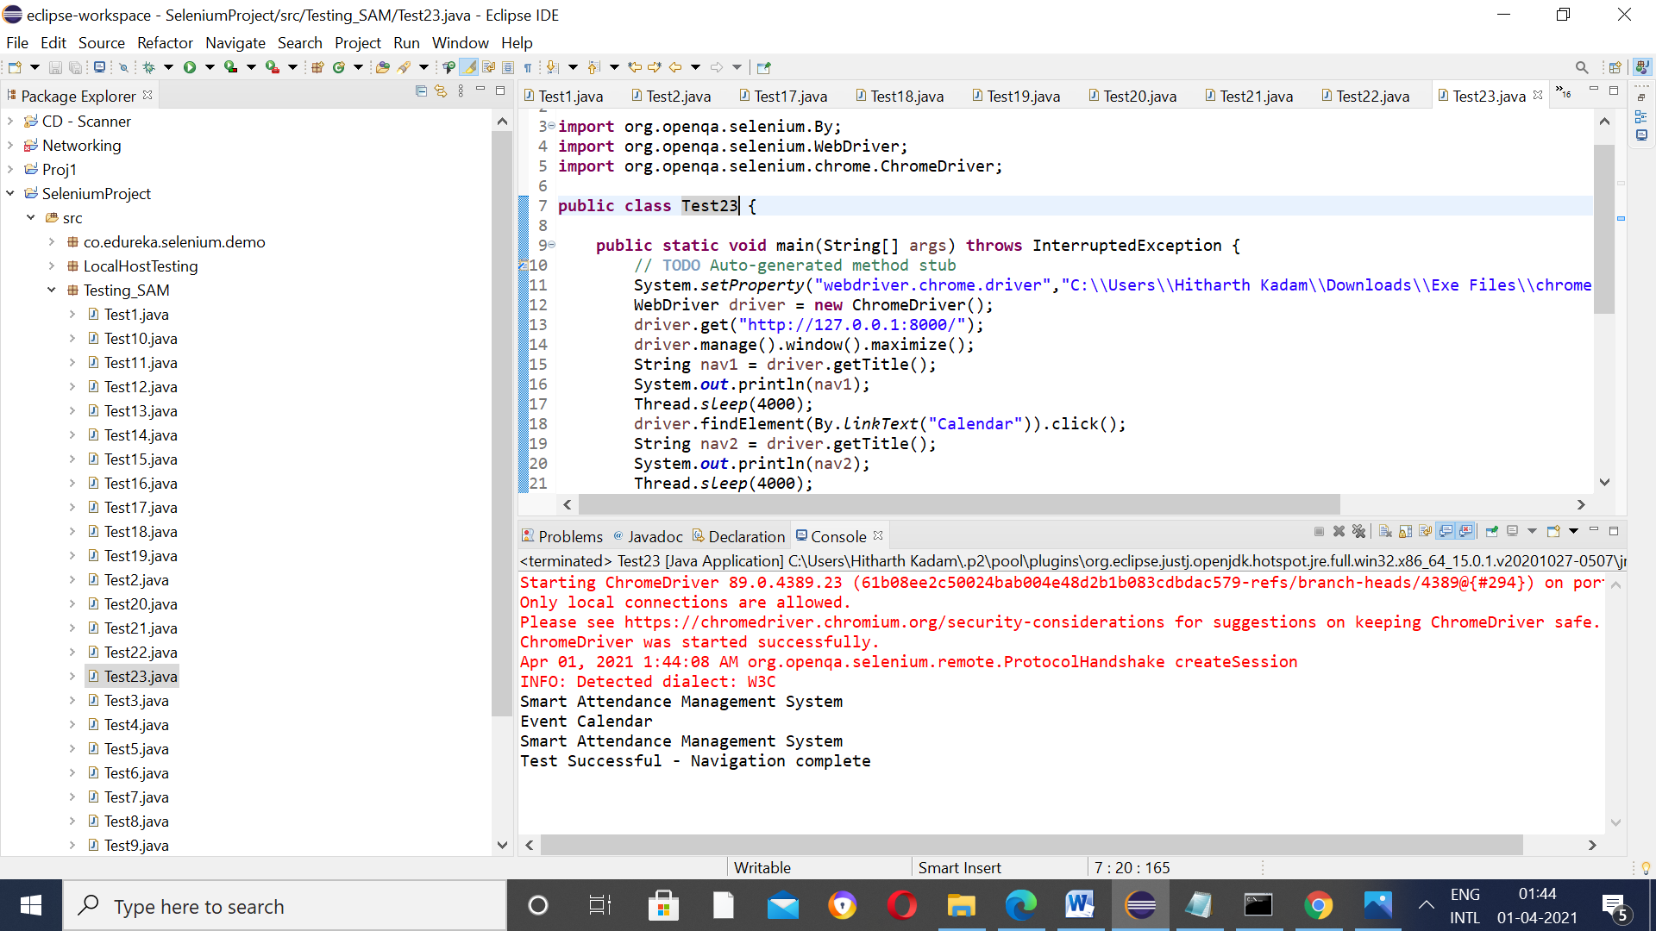

Test Case 24 – Check Navigation from the Login Page

